AUP : Agency for un-realised projects : submission :

1.0 The A.U.P. - Agency for un-realised projects - open call invitation states:

1.1 “Though the state of being unrealized implies the potential for realization, not all projects are intended to be carried out. In other instances, artists deliberately leave works incomplete, to record interesting "failures" or experiments. Other planned projects involve consciously utopian, non-utilitarian, and conceptual spaces that were not made available for realization. Whether censored, forgotten, postponed, impossible, or rejected, unrealized projects form a unique testament to the speculative power of non-action.”

1.2 Foreword
‘histories’
The submission constituted here, to follow, below, will comprise of a set of miscellaneous samples from “cat.rais” a design for a ‘simulated’ (pre-conceived) catalogue raisonne determined in 1963 for the representation - and subsequent, deferred, presentation and publication, - of an oeuvre.
The date marked the the completion of a series of conventionally formatted evidences of orthodox activity: works - paintings etc., post 1959, (culminating in an empty, newly purchased, 6’ x 4’ stretched canvas,- from the “Prime” register of works,) and the (re-)commencement of an ideation of/for a life-term of performance procedures centred in and constellated around the intent to identify the meaning of the terms ‘art work‘/‘artist’ and adopting the strategy of the pre-determined design and production of a meta-figure: i.e., the mimetic (en-)acting (-out) of the stereotype which constitutes the figure of the persona ‘artist’ and thus the simulation of it’s convention-determined, (equally) stereotypical manifestations and their protocols, dominated in the master-representation as magnum opus: ‘the oeuvre’. This programme intended construction of an hypothetic, experimental case of art-student/encandidature, mapping, testing and and documenting the procecedures of generation and development of the persona (‘artist’) towards the conference of art status to its subject-protagonist and the residues of performance in analogue of the orthodox modes of their production. The course of such a performance was posited as constitutive of a demonstrative format of definition of/for the ‘art’-status tropic appellations including determination of necessary conditions of their ascription/attribution.The catalogue-work considered the format for the documentation and archivation of ideational works succeeding in an elusion - by elimination - of necessity for other/further material demonstration /instantiation previously perceived as the unique means of their manifestation/ontological definition.
This ‘life-term performed-proceeding’ devised for long-delayed re-lease thus constitutes the source/resource of material from which the submission format derives via a number of auto-miscellaneous samples - all of which satisfy the criteria for submissions predicated on their having possessed no earlier ‘publication‘ form of occasion/event/performance.
The formats from which they are appropriated are the continuous, under-construction, several, web-sites,(in parallel and analogue with ‘oeuvre’ which they then come to represent,) construed as the formats of/ for the initial modes of publication of the several elements and formats of the works comprising “cat.rais” the catalogue-work. These are characterised by the titles for their several publication projects within the genre
“(P)-review : p.p.p. (publication project programme)”, which interrogate the significance of the publishing act/event as pro/de-clamation on the assignation/ascription of ‘art’ status to ‘work’/‘worker’ alike, by succeeding the transfer of the samples from original private/covert condition (via semi-covert/semi-overt) to fully-overt condition/status.
Thus, the current submission constructs and initiates the occasion for/of one of these projects:

2.0 : submission project title1:
“(P) review : p.p.p. 5 (publication programme project ) (5) : submission/rejection register: aup ” (2012)

3.0 : submitted work title :
“cat.rais. (prospective retrospective) (1962 ongoing ) : sample index ‘a-g’ ”

4.0 : synoptic : statement :
The submission consists in the submission documentation. This is ‘realised’ only in its present format: as a private textual documentation of an ideatic proposal. The constellation of compositive elements comprising the proposal have (in whole, as in part,) only a privatised ontological - and semantic - status: they remain un-published. In all these senses they may be perceived to satisfy the criteria of referens of the expression ‘un-realised’?2
The submission belongs most significantly to an extensive programme of works which address the issues of procedure and performance of ‘publication’ as possible necessary condition of ascription of ontological/art status.3
The intent/content of the project of the submission - as an element in the submission/rejection chapter register of works, - is the appraisal of the transference in/of significance effected by its reception/rejection: i.e., consistent with the ‘publication project programme’ of works to which it belongs (as project 4), in producing an instantiation of transference from covert (private = un-published,) to its semi-covert/semi-overt condition/status via its contingent condition/status of quasi-publication as ‘unrealised’ project in any arbitrary mode AUP decides to ‘publish’ (it). This intends, again consistent with the other ‘p.p.p.’ projects, an emphasis in explication of the actual role of the publishing agencies in the production of ‘(art) work’/‘(art)ist’, as pre- rather than post-production practitioner and explicit co-collaborator, and thus positioning the originating agent as ‘editor’ rather than ‘author’.

5.0 : submission project specification:
The submission provides a miscellany of instances of formats of work-documentation comprising the catalogue-work4 as a mode of its representation:
intent : “cat. rais.“- is the design for the device of the (readymade) format adopted (in 1962,) for the uniquely textual documentation of extant work, post 1959, and (then) subsequent ideated ‘work(s)’ as the preconceived form for the material representation of ‘oeuvre’.
content : the piece collates a number of sequentially-designed, alternate formats for the representation of the ideated works, each considered to display auxiliary aspect, and serving the material perpetuation/amplification of the work via a procedure of repetition eluding requirement for additional intent/content.

The submission content comprises:
a the foregoing foreword
b ‘card index\index cards’ format samples (first docu-format)
c ‘art work programme’ format samples (second docu-format)
d ‘memoranda of agenda/proposal/resolution’ format samples (third docu-format)
e ‘lex index’ format samples (fourth docu-format)
f ‘notes on procedure’ format samples (fifth docu-format)
g ‘status quo-te‘/‘centi’ nexuses (‘edition’ register) format samples for two works

Notes
1 The submission constitutes a work (within the submission/rejection register of the (P)-review p.p.p. chapter) and thus within the publication programme.
2 The ‘aup’ (and its invitation of submissions) voices its strength as its own version of paradox: begging the question: “what is the definition of the condition ‘unrealised’?” Antinomy resides/obtains in the issue arising on receipt of the submissions: are they then/yet so: ‘unrealised’? In effect is ‘unrealised’ synonymic with ‘un-published’? If so, and their arrival constitutes the primary condition of their de-privatisation/publication, then may they thence/hence be considered ‘realised’? Or, - if this is not perceived/considered to be the case, - are they become un-’un-realised‘ only on the occasion of their subsequent, deferred, publication at some later stage before a ‘public’ - that is, beyond the confines of the agency?
The issue coincides precisely analogously with this submission - consistent with the entirety of works described by, and constituting, it within the catalogue-work - which seeks the explication of the various conditions and states of works at respective stages of their ‘construction’: the transfer of status/condition between their pre-publication/ ‘private’ mode and that of their ‘publication’ (and dissemination format(s) and contexts of the covert-overt transfer sequentialisation). What is the nature of the transfer in/of condition/status and, more specifically and relevantly, in what/wherein resides its significance. What transformation in meaning may be observed to have occurred?
3 A complete deposition of the bases for/of the holistic project (‘oeuvre’) is not here considered appropriate for relation - suffice it to clarify that a seminal intent includes an aspired explication of the role of ‘artist‘/‘art work‘: locations of means of its definition/identification/function. The design and construction of ‘oeuvre‘ and its representation via the format “cat.rais.” intends this object, employing the strategy of late (deferred) publication as a device capable of confounding pre-instituted ‘histories’. It is informed/performed by a programme of mimetic en-actions of stereotypical characterisations of the persona ‘artist’ and its residues.
4 [It may be validly posited that the intent/content of “cat.rais.”/ ‘oeuvre’ is made in address of this specific issue: that of the (ontologic/semantic) condition/status of the (tropes) ‘artist’/’art work‘ (in terms of ‘how/when’ etc.) i.e., the question of the ‘realised‘ state.(Vide supra). The condition/status of all the works, as documented in the archival format of the catalogue-work rest/remain as demonstration, - in this, - uncertain,- mode: ‘in-question’ format - and awaiting formats sites and ocacasions of (a) deferred ‘publication’.]

6.0 Representative instances of several formats of documentations of works : samples :

6.1 Sample : item ‘a’ : card index\index card :
The sample refers to the first catalogue format for representation of the miscellaneous selection of work(s) : cat.rais. / Scull offer transfer strategy / Fraser show device / (existence I & II) / product / work [all works 1962/3]

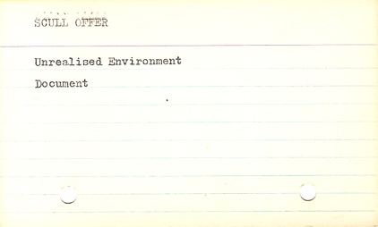
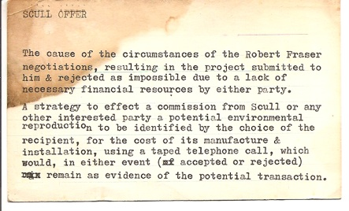
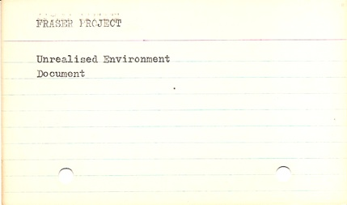
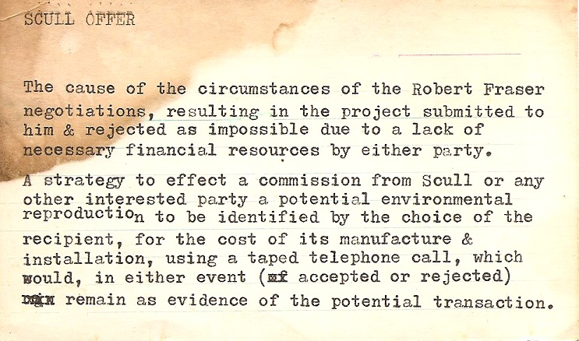

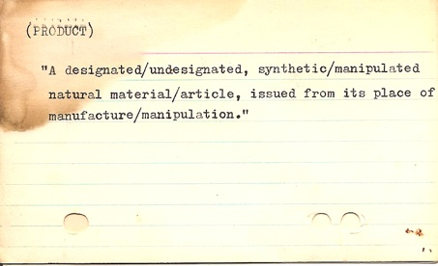
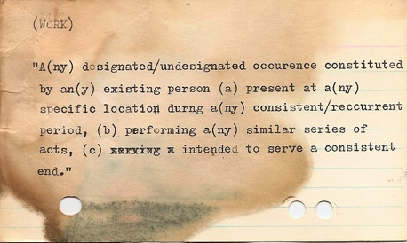

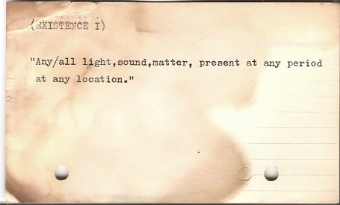
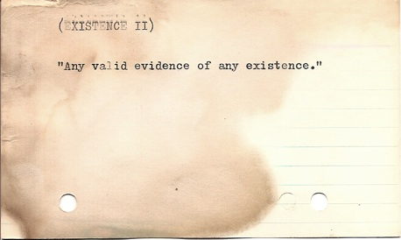

6.2 Sample : item ‘b’ : artwk. prog. spec. :
The sample refers to the second catalogue format for representation of the miscellaneous selection of work(s) : prospective retrospective I : a preview of items from the catalogue raisonne / catalogue raisonne : a presentational format for the publication of a collection of works 1959 onwards / untitled (representation) / decimal system

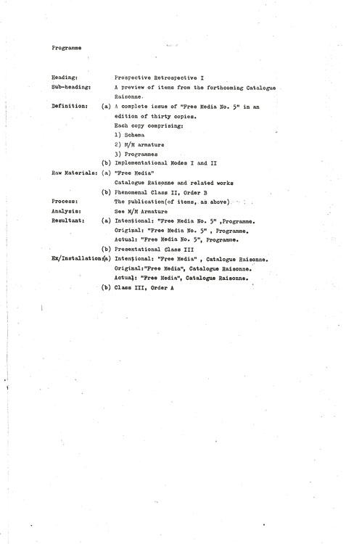
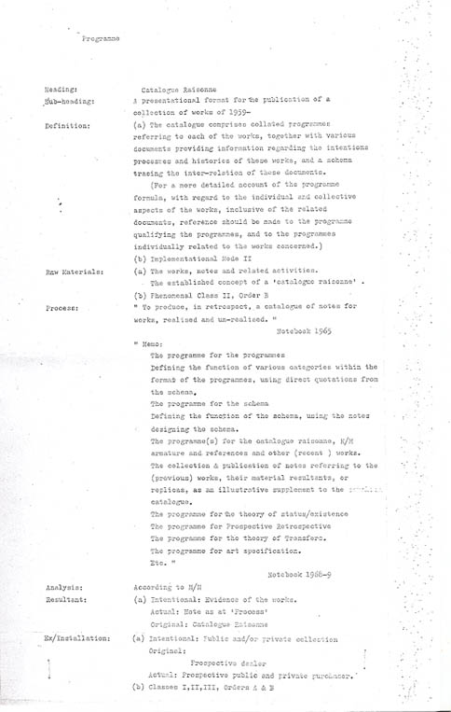

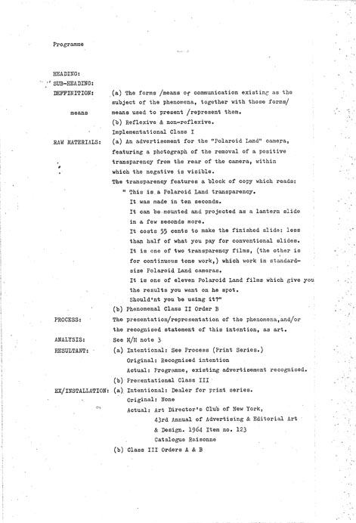

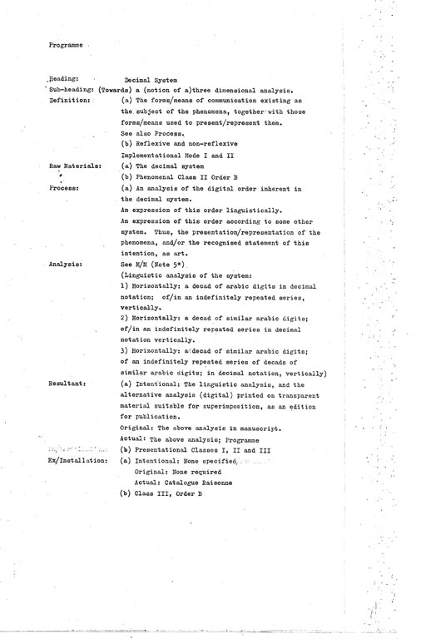

6.3 Sample : item ‘c’ : certificate of witness and collaboration :
The sample refers to the third catralogue format for representation of the miscellaneous selection of work(s) : existence I & II / product

Certificate evident of witness and collaboration

FOR product *

The intention to notify
The existence of the above-designated work

on the part of the initiator (jake morton)
by the agency of the witness/collaborator (mart northover)

endorsed by witness of communication/collaboration

signed dated / / 1964

- “ a designated/undesignated, synthetic/manipulated material/immaterial article issued from its place of manufacture/
manipulation”
Certificate evident of witness and collaboration

FOR existence I & II *
The intention to notify
The existence of the above-cited work

on the part of the initiator (jake morton)
by the agency of the witness/collaborator (george taylor)

endorsed by witness of communication/collaboration

signed dated / / 1964

*existence 1 : “Any/all light, sound, matter, present at any period at any location”
existence 2 : “Any valid evidence of any existence”

6.4 Sample : item ‘d’ : memoranda of agenda/proposal/resolution :
The sample refers to the fourth catalogue format for representation of the miscellaneous selection of work(s) : cento nexus: deferral/meta-role: Derrida / re collection as procedure / edition chapter/register : centi/status quo-tes nexuses / cento nexus: biblio-pieces / cine/vid & album chapter/registers: everybody-everyone:passersby-passingby suites / seigelaub publi-serie piece / non-object formula

to : memo date : 2009
from : cento nexus : edition chapter/register

Memorandum

AGENDA / PROPOSAL / RESOLUTION

“cento : on deferral / meta-role” * [edition chapter : cento nexus]

re : meta-role / deferral
‘ differance and deferral’ : re cat.rais. / oeuvre : ‘’immediacy fallacy’

...Derrida......attempts to show the very possibility of opposing the two terms (speech and writing) on the basis of presence versus absence, or immediacy versus representation is an illusion since speech is already structured by difference as much as writing is.

To mean is automatically not to be. As soon as there is meaning there is difference.

Derrida’s word for this lag in any signifying act is “differance” from the French word “differer” which means both “to differ” and “to defer”.

[Meaning “active non-self-presence, both in space and time”. (Note, page 45 of “Outwork”, Derrida, op.cit.)]

Derrida attempts to demonstrate that differance inhabits ...what appears to be the immediate and present.

The illusion of the self-presence of meaning or of consciousness is thus produced by the repression of the differential structures from which they spring...

(Source : Johnson, Barbara, Translator’s Introduction, in Derrida, Jacques, “Dissemination” University of Chicago 1981, Continuum, 2004.)

*ref.: deferral (of publication) and the meta-role (declination/deferral of the role of recognised practitioner and adoption of the role of candidate/student/sample: observer/commentator/example) adopted as elemental structural, functional and strategic features of (P)-review : publication project programme (p.p.p.)

to : memo date : 1968/9-
from : notebook

Memorandum

AGENDA / PROPOSAL / RESOLUTION

Make a work around the issue(s) of (the activity/ies of) collection. On the bases of the significance/meaning of collection - the question(s) of its analogue with the art work, hence as a work of art (-production) : the construction of an aesthetic via a procedure of presentation of its instantiations; the construction of an identity instantiated by (others’) works; the principal/centrality of significance of discrimination/selection as productive activity, - par excellence.....

A proposal for prosecution of the resolution is to invite artists to exchange a work (in theory if not/ rather than in practice, with documented agreement).

A further proposal is the collation of extant material evident of the collections of a selection of recognised artist figures.

to : memo date : 1965
from : notebooks

Memorandum

AGENDA / PROPOSAL / RESOLUTION

re : EDITIONS 1965-

- centi, (ii) status quo-tes

“A series TRANSCRIPTS (IONS)

A survey of citations which apply (can apply, can be applied,) to issues, attitudes, works activities, productions as transferred descriptions, i.e., which share/transfer their reference with/to the works.)
(Use (this) as an a/w prog and memo.)”

to : memo date : 1972 onwards from : notebook

Memorandum

AGENDA / PROPOSAL / RESOLUTION

Cento nexus : Editions chapter/register

bibliographic piece(s) :

- a trace and documentary log of bibliographic references from book to book as a chain
- all the bibliographic references in a book printed as the text of this one

to : memo date : 1962-/2012-
from : notebook

Memorandum

AGENDA / PROPOSAL / RESOLUTION

to : cine/vid and album(still) chapters/registers :

everyone/everybody nexus / passersby / passingby suites / persons set : ( for mart )

a series of cine/video and still photographic sequences of passing individuals and crowds, in motion:

a : static camera : (i) looking onto street, (ii) looking onto crowds
b : mobile camera : while walking, looking onto approaching passing (i) individuals, (ii) crowds

to : memo / archive / Seth Seigelaub date : 2011
from : notebook

Memorandum

AGENDA / PROPOSAL / RESOLUTION

COVERT publi-serie project

Intent to give a copy of the draft version of the (P)-review : p.p.p. (1) communique (minus Appendices,) to Seth Seigelaub as a covert publication, (audience of one.)

[Intended to be considered as a mutual celebration of the period of passage since his January show catalogue (1969) co-incident with that of the dissemination of the communique.]

Note:
Follow with a re-issue of the final form inclusive of Appendices and a copy of this memo with explanatory note as the formal invitation to contribution of comment/ary..

to : memo date : 1963
from : notebook

Memorandum

AGENDA / PROPOSAL / RESOLUTION

non-object formula 1963

a draft for a format for the comprehensive representation and specification of an index of the totality of physical/material features/characteristics of material entities, capable of satisfying the necessary requirements for prescriptions of its reproduction.

draft for a system for the systematic substitution of the specified index of features of a specification as at above, for an alternative index of a random selection of dissimilar ones.

The intention was the ideation of an entity indifferent to pre-conception.

6.5 Sample : item ‘e’ : lex index
The sample refers to the fifth catalogue format for representation of the miscellaneous selection of works

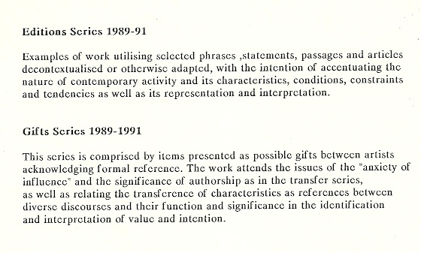
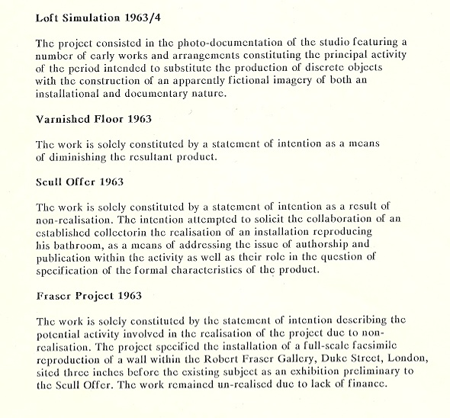
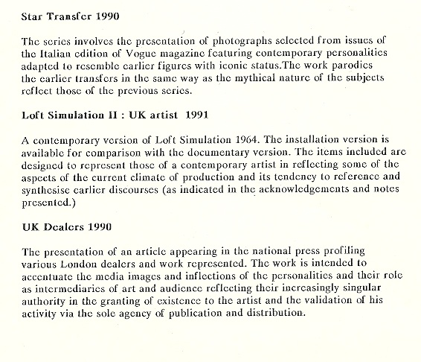
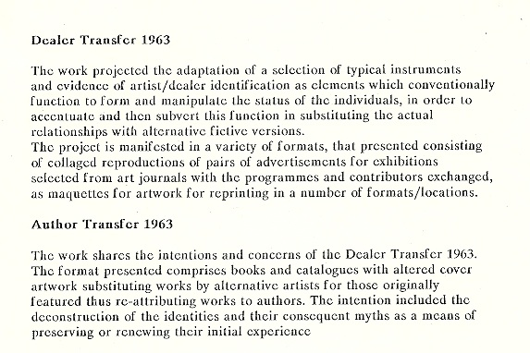

lex index
(From Memoranda of Resolution / Notes on Procedure )

? and victor/toto : 33w67
(henri-pierre roche/marcel duchamp : “studio-work/prop” instance)

The piece is constituted by the documentary representation/presentation of the photographic survey essay presenting/representing Duchamp’s studio interior of 1916/17, at 33 W 67 street.
(N.B. The documents are also filed within - as an instance - empiric surveys chapter/register :
studio-works/studio-props nexuses.)

intent :
The work intent consists in the posit and evidencing of the thesis that the original perception/intention/purpose of Duchamp for the items was that of their (non-art,) ambience-function as ‘interior-decorative’ ‘studio-props’ and the demonstration of significance of the elapse in their publication/exhibition as artwork as indication of the delay in their re-perception/reconsideration by him as artwork (Readymades).
The intent includes the indication/consideration of the significance of the formal means of their (private) documentation - in the format of the Roche photographs, - as distinct from their (public) exhibition, and the implication/significance of this determination.

content :
The work content consists in the preparation for presentation/publication of reproductions of the suite of photographs taken by Henri-Pierre Roche of the views of the interior of Marcel Duchamp’s studio in New York at 33 West 67th street, featuring the installations of his selected objects later entitled Readymades, (and later considered by him as a part of his oeuvre,) as filed within the archive catalogue (cat.rais.) within the empirical surveys register of studio-works (works comprised by/of representations of the studio), and studio-props (items forming the ambience of the studio) together with drafts of the notes on the significance of the feature of his belated perception of their art-status.

lex index

album (1) (1961)

The format of the album: the adoption of the book format for collated documents,- is one of the several early designs of/for formats (generically entitled ‘models’ in recognition of their prototypical intention and status as works prior or preceding conference of art status by peer and public adjudication,) for presentation and subsequent potential publication of works (post 1962).

This original incidence of the ‘album’ format was a work made in collaboration with the late Martin Northover, and initiated together with him for the collation and presentation of the work “album”:(1961) a, potentially infinite, collection of head shots of passers-by as documentation of a design for a life-long work conceived as a demonstration of the orthodox prescription for the role of the artist requiring construction of a programme of perpetual, repetitive activity in performance of the orthodox role/persona.

A reprise as reproduction of the piece is planned as a part of the nostalgia chapter/register, to become an instance of the (P)-review :p.p.p. (publication project programme) : covert-overt programme of works. An instance of this is the virtual album cat.rais. : ret docs : sample distributed via invitations to visit the dedicated web-site of its publication.

lex index

Covert publi-series chapter/register : submission nexus/rejection nexus

A group of works which consist in documentation of submission to available opportunities, for the presentation, representation, publication, etc., of ‘works’ and/or recognition, (re-cognition,) in the role of the persona ‘artist’ together with the resulting effects or responses.

The project intends demonstration of the primary role and function of the aspiring subject/ ‘artwork’ (deemed as functioning as the subject-logo, or primary subject-representative icon,) as the representation (re-presentation,) and recognition (re-cognition) of the subject in the form of the persona ‘artist’.

It thus seeks emphasis of the essentially desirous condition of the art-aspiration/aspirant, and the nature of longing which inflicts it.

lex index

re : cat.rais. : taxonomic hierarchies :

1.0 The archive of the cat. rais. documentation of the oeuvre is dually comprised: the paper, actual version and the subsequently-transferred, facsimile, digital, virtual version.

2.0 In both cases therefore the hierarchic arrangement of the catalogue raisonne is initially ordered according to the chronological sequence of development of its several alternative formats of registration (A) of works.1

3.0 From its initiation in 1963/4 there have been to date six formats for the registration of documentations of works.(A)

[Each state or condition of the consecutive documentary formats is designed in order to amplify and augment the representation of works by explications of details and aspects of the works considered to be less available or transparent in earlier formats.]2

4.0 Within each of the consecutive registration formats (A) there are developed a number of modes of indexing (B) of documentations of categories, or types,(C) of works.

4.1 These notionally include:
4.1.1 Chronological index of works
4.1.2 Titular index of works
4.1.3 Presentational format index of works
4.1.4 Publicational format index of works
4.1.5 Taxonomic format index of works

4.2 1 The proliferation of the modes of constellation of work indexing is intended as a
means of explicit demonstration of the criterion of artificial requirement of orthodox
prescriptions for oeuvres as primarily significant pro rata with quantitative value.

lex index
From : Notes on Procedure

“product” chapter/register : “display” nexus (&tc.)
The product register of works intend a critical appraisal of the essentially, exclusively material nature of the conception of ‘production’ as focus of aspiration and performance of action within human experience and development, within Western, culture - (and seen as at the expense of ‘symbolic‘ performances.) The intended representation and its explication of the influence of this Western cultural tendency: that of the predominant privileging of value of the material over the intellectual and ‘symbolic‘, provided within this registry of works takes account, and seeks to demonstrate, the formative effect of materially dominant concepts of production within the wider culture, responsible for its reflection within, and influence upon, mechanics and performances of the art domain in terms of the enduring division of value(s) between the market and the symbolic which is to be discerned within late (mid-century,) modern art history and increasingly markedly within its contemporary status quo. This bifurcation, - marked, by conventional art-historical accounts, in greatest relief perhaps at the end of the 1960’s with the emergence of emphasis on the relinquishing of the essentially, or predominantly necessary, material nature of the art work, - remains a central, perpetual issue and pre-occupation underpinning the contemporary bases of praxes/productions.

lex index
[from notes on procedure, memoranda of resolution]

“significances/meanings’ chapter / register* :

a series of works presenting instances of representations of art ‘in-use”
encompassing art forms/types of secular manifestations of receptions / reactions / interactions with art as encountered and perceived within a secular context: ‘in the world’.

intended as a survey in review of a mode/means of location of significance/meaning distinct from that of interpretations made within the realms of instituted disciplines of formalised - theoretical, critical, historical, museological or marketing, - domains, and with amplified reference to the meaning produced and significances displayed by/within the manners in which art is experienced, acknowledged and reacted to/with within the culture at large, as located and determined by its several forms of ‘publics’/‘audiences’ and the forms and formats in which it is manifestly presented before and encountered by these.

The justification for this procedure is predicated on the Wittgensteinian maxim “meaning = use “ , itself an insight, psychological in nature and type, [and (recognised by Duchamp,) as supporting the initially radical function(ing) of the Readymade.]

lex index

*AAAAAAAA : Acronym of anonymous association for agency of art as auto-
advertisement agenda

re : co-strategy for a mode of prosecution of covert/semi-covert publication / for mode of mimetic representation of ‘artwork’/’work of art’ :
: the instantiation and demonstration and investigation of the device, and its strategy, of the nom-de-plume; the pseudonym :

the formation of an acronym as a code for an agent/agency dedicated to publication - as discernment of (the) primary function of art work/industry, - which, by virtue of being comprised entirely by the initial letter of the alphabet in sufficient repetition is capable of ensuring its presence as the initial entry in all forms of index, catalogue, archive or directory. Adopted for deployment as a mode of cryptic, anonymous, encoded, arcane representation as (‘empty’) mimetic signifier - analogue - of/for art-’productive’ activity and its residue(s) (and thus mimetic model of the orthodox protocol for the art work as that of mute display).

lex index

*AAAAAAAAA/A9 : acronym of anonymous association for agency of art as auto-Advertisement Agenda
[from : notes on procedure :

re : co-strategy for a mode of prosecution of covert/semi-covert publication / for a mode of mimetic representation (analogue) of ‘artwork’/’work of art’ :

the formation of an acronym (logo/icon/code) as a cypher for an agent/agency dedicated to (empty/vacuous) publication - as discernment of (the) primary function of art work/industry, - which , by virtue of being comprised entirely by the initial letter of the alphabet in sufficient repetition is capable of ensuring its presence as the initial entry in all forms of index, catalogue, archive or directory, - for deployment as a mode of covert/semi-covert registered (cryptic, anonymous, encoded, arcane) representation for publication as (‘empty’) mimetic signifier - analogue - of/for art-’productive’ activity and its residue(s).

intent/content :
a : critique of conventional prescription for mute, encoded, arcane, non-explicit,
cryptographic display-format of conventional prescription of/for art-products
b : critique of primacy of function of/for art-activity/art-products as agent/agency of
en-signment / ensign-ment / assignment (deployment/distribution/publication) via
representation(s) of (‘signs’ of )(the) persona ‘artist’

Notes in explication:
The intent is the demonstration of the nature and function of the art-work determined by conventional prescription as having for its primary function the advertisement by publication of the representation of the persona ‘artist‘ - which for the figure of the individual subject is a cipher.
The art-work is thus determined as the announcement of a notice -a proclamatory/declarative act (manifesting a presentation to/before the public,) via/of a sign or mark - in the form of a residue of an activity (a performative act, ) - prosecuted by the actor (persona,) representative of the metier (constituency of the discipline).
The piece intends to demonstrate the lack of significance of the constituent detail of the mark in that it has no relation to this primary function, it is arbitrary in terms of intent/content (function/significance). Similar in nature to a word, in this it closely resembles, may be accurately considered and described as, a logo, absent of mimetic character or function.
[The nature and function of the detail characteristics of the art-work serve a secondary, and un-related, purpose, which is also conventionally determined (by inheritance from earlier, distinct applications/activities,) as the display of skills and acuities of an individual subject - performing as a craftsman / artisan / connoisseur of quality of execution and discernment of appropriately conformative reference, - for assessment of value, privilege and status in terms of comparative merit by consideration within a constituency of like-acting performers as peers.]

{Thus, for example, the works of ‘prime series’ (void canvases,) ‘empty notebook’, ‘Fraser project‘ (solely involving specification for/of the ‘covert‘ instantiation of the ‘prosecutor‘/‘persona‘ by the facsimile reproduction of an existing wall immediately before its original, as the strategy for the validation, of “Scull Offer Strategy’) ‘Scull Offer’ (solely involving the covert instantiation of the prosecutor/persona by the proposal that the collector construct a facsimile reproduction of one of the rooms of one of his residences,) ‘cat. rais.’ (the production of several formats for the representation of extant works and the documentation of ideations and proposals for/of consequent/subsequent works,) these amongst other pieces adopt the format of the vacuous sign, that deprived or emptied of its conventional detail of typological characteristics in emphasis of its primary role and function.)

lex index

re : cat.rais: documentary formats:
1 art work programme / 2 certficate (evident) of collaboration / 3 memoranda of agenda/proposal/resolution

Note
1 The ‘art work (a-wk )programme’ format is the initial design for documentation of proposals for works. It’s formatting intends a proto comprehensive attempt to analyse and determine - and thus explicate - the salient (functional/operative) features of the work(s) in particular identifying the intent/content components and the modes and means (forms/formats) of presentation form/means of representation) and publication t(communication to an ‘audience’/‘public’) thus providing for the recording of successive re-presentations/publications in alternative formats: a strategy consistently adopted as a means of the (re-)generation of the work as/in quantitive amplification of the oeuvre/cat.rais. while effectively eluding the multiplication of initial/primary-level intent/content element.
2 The ‘a-wk prog’ document format precedes the ‘certificate (as evident) of collaboration’ (cert.collab.): the second format of documentation adopted as a documentation of those works which were disclosed, as a mode of publication, to a selected individual (‘the audience of one’) as a preliminary form of investigation of the conditions, relations and value (necessity,) of publication to attributution of (art) identity/cognition/recognition/status etc.
3 The third documentary format: ‘memoranda of agenda/proposal/resolution’, is designed to facilitate the logging of the process of conceptualisation and subsequent stages of development of work and permitting the relay and dispersal of, and, at the three successive stages/conditions as analysed in/by the documentary distinction of the format.This grants via the memoranda format the again amplified cataloguing within cat.rais. and provides a means and location for/ of documentation and collation of these successive states/conditions (of the works) both in terms of presentational and publicational form, occasion and sequence.

lex index
(from : notes on procedure)

re : EDITIONS 1965- : centi, (ii) status quo-tes

from : notebooks : notes on procedure, (paper condition)

“A series of TRANSCRIPTS (IONS) / TRANSFERS (c.f., transfer register, cat.rais. archives)

A survey and transcription of citations which apply (can apply, can be applied,) to issues, attitudes, values, works, activities, productions, residues, as transferred descriptions (of “oeuvre” and/or its intents/contents)

NB : (Use (this) as an a/w prog and memo.)”

lex index
from: notes for lex index

re : “editions” chapter : “status quo-tes” register / “centi/centones” register (1964/5 onwards)

The “editions” chapter of works is comprised by two registers/categories of pieces: “Centones” and “status quo-tes” consistently characterised by the feature of the procedure and format of (re)citation.

Both the registers of works appropriate, adopt and recite entire texts, passages, statements, and phrases which are sufficient to satisfy a criterion of being capable of application to - as adequate descriptions of, (i.e., having as reference class-members,) - works/procedures/residues/publications of pieces from “oeuvre” / “cat.rais.” where the cites are thus adopted for the transference of their reference (their extension in logical terms,) to/by that of a/the representation(s) of the work(s).

Hence the works may be said to perform via involving a procedure of transference - as replacement or in co-existence with, i.e., co-extensively, - of the subject(s) work to the site of the recited textual form’s reference and thus of assuming identity of/with the condition/status of its’ original referent. Alternatively, one might express this inversely as the transference of the terms/recite to that of reference to the domain or class of the subject(s) works, or, again, as the transference of the extension of reference of the recited terms to include those works within the class(es) of it’s reference, and so on. In this respect the registers are a sequence of/to the “transfer” register of works, (1964 onwards), (c.f., “lex index” : “transfer” register.)

In all cases the recitation procedure functions as to provide a meta-linguistic representation and description/specification of the subject works in that it refers, at one remove from a subjectively formed version; it provides a suitably non-subjective representation and reference - a ‘readymade‘ version of characterisation of the work(s) to which it is applied but emphatically, after the work’s initiation (moment.)

This meta -condition is especially relevant in reflecting the status desired for the subject as - temporarily: at the moment of initiation and presentation of the work (oeuvre), at least, one assuming a stance/posture outside the role of (the) ‘artist ’ (where this term refers to the persona: the role, or characterisation of the player/performer of/within the role, - i.e., according to that determined by a sufficient application of the predicates determining the class ‘artist’.) Such a meta-role is required in order to preserve the status/condition previous to the ascription of ‘art’/‘artist’ : involving the retention of the status/condition of candidate for such ascription, i.e. as applicant, (hence a form of amateur.) This provides for the possibility of investigating, testing and demonstrating the precisely necessary/sufficient conditions of ascription(s)/allocations of the status/condition/description ‘art’ and of the terms and conditions of entrance/affiliation to/with the membership to the constituency/class of entities represented by the term ‘artist ’, in search of definitions for these.

The dual registers of works (“centi/centones” and “status quo-tes”) within the “Editions”chapter thus announce and mark, as note of, the subject’s exile from, - and his/her consequent longing, as desirous candidate, for, - identification with the persona ‘artist’, by a process of ascription of entitlement, and thus via an affiliation to/with the peer-constituency ‘artist’ . The adoption/transfer of the characterisations of other’s work (i.e., as the reference of the citation,) functions as a marker of the melancholia of the isolation at the centre, - and thus as the sign as indicator, - of the unrecognised entity, or non-identity of the appealing subject. The works thus seek to offer notification of their fraternity with those described in the original reference of the selected textual representation as a means of validation of appeal/request for acknowledgement of their adequacy for affiliation to the field of their (‘art’) location and status.

The distinction of the registers resides in that the “status quo-tes” pieces’ recitations are located as/from contemporary instances of descriptions and reviews of extant publications/published (visual art-) works i.e., as publicly announced and hence recognised (as) artworks, and/or of their characteristics and/or theoretical bases. Hence, contradistinctively, the “centi” or “centones” register discriminates texts of a more abstract, often purely theoretical nature, which are not exclusively representative or treating of (visual) ‘art’ -work(s), but rather of ideational discourse(s) or practices from a wider spectrum of domains and interests which nonetheless remain particularly capable of valid application as representations of method, process, procedure - and their intents/contents and residues, - of the subject(‘s) work/oeuvre.

Notably, the application of the extant nomenclature (‘centone’ or ‘centi’ ) itself to the work1 - and thence, by extension, to the essay which seeks to secure its exposition, comprehension and value, - constitutes an instance of, and thus seeks to identify and demonstrate, the procedure/practice of the “Editions” register‘s productions with the procedure and form of the citation of extant available, published and classified material. Thus the notification/demonstration of this feature is made in/by the piece ”Centones/centi” constituted by the adoption/recitation of the entire paper which seeks to explicate and historicise the formation/procedure and use of the (ancient) pre-existent textual form/practice.

Significantly, (and thus emphasising and validating the basis for the use of the procedure (of appropriative recitation,) in satisfaction of the intentions (the instance of this specific application,) of the form/procedure it seeks/serves to effect and support,) the location of the cited text explicating the history and methodolgy of the practice and productions of Centi/Centones followed (by two or more decades,) the practice of textual appropriation/recitation and re-application, -or intertextuality, - within the works, (at which only moment, the adoption and application of the trope was made to the (previously untitled,) register of work within the “Editions” chapter. )

Notes
1 “Centones/centi” is the (working) title of a piece which appropriates and re-presents facsimile a paper relating the origins history and theoretical evaluation of the antique literary form of the ‘patchworking’ of extant texts in the generation and formation of text. The paper/piece is to be featured as appendix for information, vide infra .

lex index
[from : notes on procedure/histories/statement on ]

nostalgia chapter/ register(models / studio sim. sets / auto-reps. / commemoration suite mod/mod set, 2009-)

The nostalgia suite, comprises the sub-sets of series of works (of) commemoration, remembrance and dedication. The suite takes, and forms, part of the general theme of ‘(be-)longing’ which permeates the oeuvre (from the outset,(1959),) and is so posited to do so in all its instances (oeuvres,) as the unique intent/motivation of praxis.

[As such, it falls within the taxonomic indexing of the catalogue raisonne ((“cat.rais.’1962-),
within the genre of works comprising simulations of the modes of representation of the artist which work to establish his reputation as artist, that is to say, which constitute the method and means by which an individual is socially (re)qualified (re-cognised as,) as to be considered so, and thus, via which persona, is effectively elected to the affiliation of his consorts and by which procedure is granted the ascription of ‘artist’ status.]

The suite is solely comprised, (2009 to date, (2011),) by ‘studio-models’ : pseudo-orthodox
visual works on/of varieties of conventional, recognised, art-connotative media: canvas and stretchers, paper, photographs, videos, xerox ink-jet, silk screen, etc.,and ‘assemblies’ and ‘arrangements’ of objects as ‘studio-props’: found /formed extant elements within the confines, perimeters and localities of the studio(s), and so forming part of and remaining/maintaining consistent links with the studio/loft-sim. suite of work (forming a part of the works within the so-titled ‘ logo-icon rep genre: studio genre’ which comprises simulated sets of artists’ studio ambiences, practiced since the outset of activities in 1957. These comprise:(Back-Lane, (1959); Marshall’s Mill, (1963/5); Phideas’ Beaux Art,( 2009); Asquith Bottom Mill, (2010- ), etc.,) and the show-sim. suite of work (Fraser show for Robert Fraser @ Fraser Gallery, 1963//4; London artist @ Lynch Site,1980, etc.,) as genres of self- representation and personification adopted as formats of/for works which seek the parody as demonstrations of these conventions (studios, shows, etc.,) functioning as orthodox, established genres of mechanisms of/for logo-ising / icon-ising of the art-candidate in servicing of application for attribution of art status.

All of the works are constituted,- following the original motivations based on the focus upon the studio as a site and ambience: a contrived scenography or set, productive and representative of art work,- by/of items or ‘props’ located there. Each work, while referencing the persons and work of the period, - my own, and those of my heroes in that golden era of 1957-64, when it all seemed to me to happen,- also originated in response to the studio furniture, furnishing, equipments, and appurtenances.

The perception of the significance of the studio - as ‘hallowed lieu’ - dates from the earliest of ‘longings’,- maybe around 1956 or 7,- inspired by photos or paintings of the artists in these, their sanctuaries, - and provided the material which later formed the empirical surveys register of icon/logo works of catalogues of their images. As locations and environments these function as icons in their constituting powerful and infused evocations, as representations par excellence, of their inhabitants. Studio-images for example of such iconic representatives/representations of the mid-century as Bacon, of Balthus, of Giacometti, de Kooning, Kline etc., which, - regardless of the merit or significance of their productions, - evocatively and impressively personify, and produce, the person(a) of the artist as a figure which informs and performs comprehension of the concept: beyond the parameters and potentialities of the oeuvre itself alone.) Ugo Mulas‘ images, of Rauscehnburg and Johns in their respective lofts provide powerful and seductive period characterisations performing as temporally prescriptive specifications of the protocols for the instantiation and installation of the figure: ‘artist’.

The initiation of the production of the suite of works was occasioned by the offer of the use of a studio for use during the summer of 2009, (of the Atelier Phidias, sculpture-workshop at the Beaux Arts Institute in La Suquet, Cannes.) The procedure adopted for production of work in respect of this novel condition/context was based on the particular species of longing which was stimulated by the return (always a condition and stimulant - of nostalgic reminiscence,-) to ‘studio practice’(s). (Equally and associatively, falling ‘on the heels‘ of the recent demise of ‘Bob’ Rauschenburg in the previous year, and emerging out of a form of sense of his loss - itself a variety and close kith of longing, - the more so in that a large and consistent part of the instance of that ‘longing’, and comprising the centre of my personal motivation, related closely to my encounter and conversations with him (in 1964). The work thus began a commemoration and celebration of him, and of his seminal relation with ‘Jap’.)

The works, commenced by the revisitation and re-adoption of the position of the ultimate painting-models of 1962: the ‘empty canvas’ and ‘blank canvas’ and ‘canvas with perfume’, canvas with fluo’ , ‘purchased canvas’, ‘divided (horizontal bifurcation) canvas (canvas with pencil-line)’ etc., all of which featured quasi-featureless, or featureless, readymade, stretched and primed canvases of the same format and size, 6’ x 4’, of the ‘prime suite‘ of works, which also recorded the residue of acts of preparation of material formats: the flax canvases for priming, and subsequently the several further stages of preparations prior to the ‘painting‘: conventionally perceived as the ‘creative’ act, were reprised, linking the procedure to the equally early (1962/3) ‘instructions suite’ of work which presented versions of imperative verbs (‘stop’, ‘exit’,etc., ) and films recording the demonstration of a variety of (simple) tasks (‘(fruit) peel’, ‘(fabric) iron’ ‘(paper) fold’, etc.).
The work continued with revisitations and re-references of figures - their characteristic/characterising gestures and marks, - of seminal early subjective relevance as the means and material of construction of residues intended as mimetic ‘models‘ of orthodox production residues and their formats: stereotypical pseudo-works which elude authenticity or innovation and functioning as mere demonstrations or samples..

The central component of the fabrication of these primary pieces remains a consistent element of the entire suite.

lex index
[from notebook

vitrines 1961/2009- (prime chapter/register)

glass ands mirror sheets obliterated/rendered opaque/translucent with paint or other material

lex index
[from notebook,1962

not-art (“Everything” / ”Every thing” / ”Every-thing”)
(A response to the encounter with the Duchampian Readymade strategy)

The nomination of literally ‘everything’ as not art (“not art” ).

Any instance(s) of any material item(s) : presentational/publicational formats to be any medium of representation of any item(s); any siting/situating of any actual instance of any item(s); any nomination of any item; any indexation of any number of item(s); any cataloguing of any media of representation(s) of item(s); any aggregation or collection of any number(s) of item(s).

lex index

re : ‘sets’ 1962 onwards :

a series of textual and/or photographic documentations of extant or designed interior scenographies or dioramas perceived as prototypes of installations for exhibitions, as sample candidates in commentary and demonstration on/of limitations of the avant-garde practice of formal variation.

an early instance (together with the contemporaneous ‘sculpture notebook’,) of the adoption of the procedure and formats of documentation - in a form of logging for record and archiving - of intent/content of/for work as a means of its presentational/publicational format, and leading to the series of suites studio and exhibition simulation sets, (1963 onwards,) and the adoption of the catalogue raisonne (1963 onwards,) as the determined format for/of presentation/publication for/of subsequent work/productions.

library
gymnasium
house beautiful
green park
scull offer project
fraser show project
studio simulation(s)

lex index
re : cat.rais.

The catalogue-work works as a guise or cover for the excercise of repetitious generation of systems of classification of extant and ongoing ideated works, proffering the opportunity for the elusion of their un-necessary material manifestation/demonstration.

lex index

re : cat rais.
[Abstract : Draft A]

The work intends elaboration of taxonomies: modes of cross-referenced, re-classification procedures serving
proliferations of contents in demonstration of: (a), the primacy of intent of/as the agency of proliferation of
publications of the nomenclature of the persona (‘artist’,) (i.e., as: logos of icons,) over (all,) other contents (in the
conventionally-determined,) orthodox function of ‘artwork’(1); and, (b), the primary significance of procedures of
taxonomy - i.e., the roles of discrimination, constellation and classification as means of ascription of comparative
significance, and hence meaning/value, as art production, and upon which all consequent issues and features are
predicated.

Notes
1 This is to describe something like an empty, or voided, signifier: referring merely, as it does, to a logo as the icon
signifying a name of a class without definition: a mask, facade, for an indeterminate concept.)
(c.f. icon/logo register in ex index in appendices, vide infra.)

lex index

re : ‘non-object formula’ - draft notes for lex index / work procedure and specification(1962-)

procedure specification :

Use of thesaurus to identify characteristics of objects, material entities, and qualities of non-material entities (thoughts, emotions, ideas, concepts etc.)

Use of these to define a random selection of both types of entities.

Then the determination of a/any random procedure/method, for the re-combination of these - in the abstract, i.e. linguistically, textually - in/as the generation of a hybrid set of characteristics in definition of a non-existent entity.

lex index

re : Fraser Strategy, 1964 : Robert Fraser Gallery show

(Ironically,) the work/exhibition was occasioned by the interest which the gallerist Robert Fraser had in the strategy designed for a work directed to the collector Robert Scull.
The intent/content of the work was the direct liaison with the collector eluding the convention-determined structures of agent/gallerist/dealer as a prototypical mode of production/presentation/publication to a public of a single individual (thus a semi-covert register publication,) and also required the collector to act as producer. It thus took the form of an inverted commission.

The strategy involved the recording of the proposal to the collector offering to invite his participation in the piece via his organisation and administration of the construction of a facsimile replica of his bathroom, at any alternative site within or without his home. (See Scull Offer Strategy: cat.rais. and lex index.)1

The gallerist requested that he be allowed to participate in the strategy - as a benefitting agent, - based on his consideration that as a collector of the works of the New York based artists whom he represented in London, Scull would be more probably sympathetic to the commission. The irony of this aspect as a potential addended characteristic proved persuasive in that from its initiation the work was not intended to be predicated upon the prosecution/production of the facsimile set, rather the intent/content inhered in the documentation and recording of the proposed commission only.

The interest of the gallerist in seeking to adopt a role which was initially intended to be eluded by/in the work, appealed by virtue of its potential to make the more evident the demonstration of the convention-determined role of the dealer/gallerist - as the conventionally unique agent of publication - by the re - introduction of the orthodox element out of sequence, and thus deprived of normalised function, and thence emphasised as a redundant element, relegated to the merely decorative, by the schedule of the gallery event to follow that of the introduction of the proposal to the collector.
This was seen as indicative of the reciprocally structurally supportive nature of relations of authority which under

Following his request the format of his role was determined as the host of a formal presentation of an preview ‘exhibition’ at the gallery. This was then designed so as to consist in covert issue of a notification of the event via direct private circulation to individual addressees of the gallery mailing list - in lieu of public advertisement: considered to function as semi-covert register of publication. The design of the exhibition comprised the facsimile reproduction of an(y) existing wall of the gallery installed four inches before the extant wall (and to include the works which remained from the previous exhibition.)
The covert format of the work intended the emphasis of the role of the piece as a critical strategy/commentary conceived to replace the provision of potential agents of connoisseurship 2 facilitated by conventional production.

1The selection of this form of specification for the action to be requested on the part of the collector was founded in the knowledge that as a renowned purchaser of works by the artists commonly identified by the media as the ‘Pop’ team, (or, more accurately perhaps, who comprised the Castelli stable,) who, pace Robert Rauschenburg, were alleged to seek to (produce) work within the gap twixt life and art, he might consider the proposal for a production the more amenable, significant, or relevant, - to both himself, and the other works within his collection,- which reproduced an extant domestic site, the implication being that this reverberate with the collected works in being an analogy of (his own personal,) reality - and, of course, that of the collected artwork. The design of the nature and form of the specified object of/for production was entirely predicated upon its appeal in soliciting the attention of the collector to the degree that the intent (as content,) of the piece be made evident while without assuming functional role or significance to the intent/content and format of the strategy constitutive of the piece.

2 This trope is here intended to reference conventional artworks and their successively aggregated function in displaying connoisseurship (thus, i.e., as its agency,) based on the selective process of discrimination of preferred characteristics for inclusion,- as the constitutive elements, - within the format of the piece, on behalf, first, of the artist, and then, with the further, subsequently added, authorities, as provided by approvals, in the forms of imprimatur, of the collaborations of the sanctifying figures of the dealer and thence collector or curatorial museologist, in their seeking or accepting the roles of endorsers, validators and legitimators, and hence agents, of the display of connoisseurship constitutive of the piece. This is to identify the function and purposes of these actors in the process or performances of the convention-determined procedures of the ascriptions of art condition or status, - initially, - and - thence, - significance/value.

lex index

re : Scull Offer Strategy 1964 :
offer of invitation to be made to Robert Scull to participate in the production of a piece
of work for inclusion within his collection

The work is the first of its type within the oeuvre (in) seeking to consider and constitute a work as a strategy, i.e., as the design of/for a device or suite of actions taken to effect a specific, predetermined result devised to produce a demonstration and explication of the extant conditions of a state of affairs: that of the conventionally determined roles, functions and inter-relations of the artist, artwork and collector precisely in the process of the prosecution of the piece.

The work consisted in the proposal to issue an offer of invitation to the collector Robert Scull to participate as collaborator in the production of a piece to comprise the facsimile reproduction of his bathroom in an(y) alternative site, within or without his own residence.1

The procedure sought to determine the contravention, by inversion, of the orthodox sequences of validation, legitimation and authorisation provided by the dealer as intermediating agent by his elusion and thus elimination, in emphasis of the similarity/identity of function of the collector in the established formula of ascription of art condition, status, significance and value.2

A corollary connotation intended was the illumination of the relations of reciprocity consisting between the three figures of the artist, dealer and collector, and their similar/identical functions in the endorsements of the features of connoisseurship represented simultaneously and jointly by/as the artwork functioning together/with the very processes of its utilisation and manipulation accorded via/in the transference of its residences and their associations with each of the individuals, as the means of their identification and privilege obtaining from their re-identifications with/as the several personas.

An intent/content of the work is represented by the feature that the role of the artist assumes/adopts that of the initiator of the proposal, while that of the collector assumes that of producer. The nature of the form of (specification of the form for the intended) production of the collector is clearly discriminated as separated from the nature of that of initiator of the proposal in its being precisely of no purport to the work of the initiator or to that of (his) proposal, and only of significance and value as that of the collector in that it provides (him) the necessary material presence which he seeks to possess and thence obtain the required evidence of connoisseurship and the potential of transfer/trade. This ideal identification of the two discreet objects (intents/contents) of the dual aspects and their roles of the constituent elements of the piece marks the distinctions in relation and function of the two protagonists as markedly evident, and demonstrates the orthodox role and function of the conventional artwork as the agent/agency of their several and distinct desires and intentions. While for the initiator, - in this case (at least,) - the work is seen as the means of demonstration evident of his intention, performance and their role within the field, and thus without need of material residue other than its documentation, for the collector it is seen as an evidence of his connoisseurship in the discrimination of value/significance (or significance/value,) as a specific type of commodity. The design of the piece seeks to reflect these distinguished, separate nature and roles of the performances of each of the dual protagonists and the means of their reciprocal relations in the conventional versions of the forms of their relations via their mutual assistance in the processes of production of their individual aspirations. Each is demarcated by the nature of their participation in the dual object(s) and procedure(s) of their dual (‘artwork’) production(s).

1 The selection of this form of specification was founded in the knowledge that as a renowned purchaser of works by the artists commonly identified by the media as the ‘Pop’ team, (or, more accurately perhaps, who comprised the Castelli stable,) who, pace Robert Rauschenburg, were alleged to seek to (produce) work within the gap twixt life and art, he might consider the proposal for a production the more amenable, significant, or relevant, - to both himself, and the other works within his collection,- which reproduced an extant domestic site, the implication being that this reverberate with the collected works in being an analogy of (his own personal,) reality - and, of course, that of the collected artwork. The design of the nature and form of the specified object of/for production was entirely predicated upon its appeal in soliciting the attention of the collector to the degree that the intent (as content,) of the piece be made evident while without assuming functional role or significance to the intent/content and format of the strategy constitutive of the piece.

2 A similar action was planned in anticipation for an invitation to participation of the museological curator.

notes on procedure / lex index

re : studio/loft-sim / exhibition/gallery sim nexuses

These dual, complementary formats and categories were partly generated (’62/3) by interest in the scenographic or the ‘set’/‘setting’ as a form which might effectively function to evade or replace that of the monopoly of the object on ‘art work’, - especially in respect of the claim on the totality made by the implications of the Duchampian Readymade, - and which might prove capable of serving to demonstrate the effective resources of the scenic as a mute communicative medium equal or improving upon that of the over-extended discrete object. To this extent they performed a formal commentary.

They fail in terms of resolving the dominance of the paradigm for production - of the totalising prescription, - of mute display as the criterion for characterisation and identification of the art work. They also fail as means of extending or replacing the strategy of the Duchampian Readymade, inherited from earlier adoptions of extant objects (‘objects-trouves’, ‘conversation-pieces’, ‘decorative objects’,) in various fields as symbols, icons, fetishes, especially in those works which consist in the re-siting/reciting of extant, unaltered, readymade, purpose-determined areas and formats1 though this propensity for such established forms, already reified into symbols and icons, was consistent with earlier works2 which were not determined by avoidance of the object.

These limitations however are purely formalist however, their performance being efficacious in terms of their intended function. Contradistinctive to this formal gesture, was the intent - following the initial proposals of simulative re-constructions (as “transfers”: part of the co-existing, contemporary suite of “transfer” works,) of extant ‘readymade’ examples,- in the studio/exhibition simulations, to demonstrate their conventional role in the construction and establishment of attribution and ascription of ‘art’ role/status to subject-candidates and to the residues of their performances (‘artworks’). These proposals of specifications for exhibition (designs) were intended to communicate in a conventional mode as connotative of their quotidian function, thus as instantiations of their - absent, - occupant: ‘artist’. Moreover, in terms of their efficacy as demonstration, they were intended in this to reproduce (as simulation) their normal roles as the representations and signs of their occupant. The procedure of transference to the display-centred/connoted site of the exhibition/gallery, emphasised their artificiality, and by which agency, devised, contrived, and contributed to their evidencing, reading and significance as signs.3

.Both, then, intend the foregrounding of their primary, orthodox roles as signs/symbols - indications/indicators - of the application of the subject-candidate to the ascription of the nomenclature, role and status of the persona: ‘artist’: for the ‘possession’ of the studio or the exhibition/gallery is that of an acoutrement peculiar to the ‘artist’. Once this ‘possession’ has been credibly attributed to the candidate-subject in the perception and belief of the beholder - audience/public - the transfer of subject-candidate identity to that of the persona occurs/is complete(d). This process obtains, regardless of the (specific) nature of contents (props) of the contextual sites. Thus the hegemonic status of the discrete object is eluded, as is the relevance and hence significance of the specific characteristics of the co-incidental, contingent props other than the indication via connotation, of the secular function of the context site. Formal/aesthetic characteristics are more than redundant, they are absent, the reading of function via the sign-value of the equipment/props evident of purposive performance is sufficient.4

For AUP submission the intent/content is the issue of the question what is the definition of ‘unrealised’; what is the range of its reference, its semantic extension: does it refer to publication; material production; physical production; exhibition; publication? And if the latter, to what forms is it limited etc.
E.g.,
“The project questions and aspires to locate terms and conditions of resolution of the ontological issue for ‘art’ ‘work’,
i.e., of the necessary conditions of possibility of (its’) existence; means of location of procedures for/of its individuation:
is acknowledgement of information of intent by a singular receptor/audience sufficient? “

If the exhibition is a simulation of an exhibition and the studio is exhibited as a simulated version for and as exhibition then an exchange in - transfer of,- roles occurs which initiates the reappraisal of their respective significance, relations and status.

Notes
1 For example: “golf-course”, “tennis court’”, “air-field/landing strip” ,”library” “gymnasium” etc. These proposals for ‘works as exhibitions’ and ‘exhibitions as works’ were rationalised in the textual piece “Schema” which construed a formulaic definition of their procedure of election and symbolic-construction entitled “M/M: MANifest/phenoMAN” and published much later in semi-covert mode in the journal Free-Media Bulletin No 5, 1969/70 (Ed,.Ted Hawkes)
(“library” was ‘performed’ in 1962/3 in the format of the ‘closing’ of, - i.e., suspension of functions within, - the school library for a period of two days, after which it was ‘re-opened’ for service. The intent/content of this work being the demonstration via display mode of the environ/context. A commentary on form/format.)
3 Influences in this interpretation: that of the setting as connotative agency, include those of the theatre or film set which function - prior to initiation of event as performance - as mute communication of a circumstance and location and suite of conditions which serve as the contextual pre-paration, the priming, predisposition of the ensuing event, or, alternatively, as the residue, the effect; the evidence of a completed one. In both cases a narrative is connoted.

2 For example: “notebook (empty)”, ‘book (dummy)” , “sheet (blank)” etc. These, though objects, did not feature, as their intent/content, a formal comment, i.e., they did not intend their interpretation as a proposal of a formal innovation - which the extant (readymade) environmental pieces initially partly did, - but instead intended a remark on their vacuous condition, and were contemporary with the “prime’ series of works with stretched canvases which sequentially proceeded to evacuate all formal (superfluous, non-functional,‘aesthetic’,) characteristics, thus remaindering the material form as the sole agent of intent, purely connotative of the representation of ‘art‘ status: the icon/logo par excellence of the ‘artist’, in the mode of the ‘studio‘ and ‘exhibition/gallery‘ pieces described. Again, a proximity, or analogous condition, obtained between these ‘empty’, evacuated pieces, and the environmental ones, in that both were eliminative of specific detail connoting ‘aesthetic’ intent/content comment, the composite elements detailing their nature (furnitures, equipage, props,) functioning as conventional, secular, non-‘art’, signs.

3 Influences in this interpretation: that of the setting as connotative agency, include those of the theatre or film set which function - prior to initiation of event as performance - as mute communication of a circumstance and location and suite of conditions which serve as the contextual pre-paration, the priming, predisposition of the ensuing event, or, alternatively, as the residue, the effect; the evidence of a completed one. In both cases a narrative is connoted.

4 A closely similar function attaches to the adoption - in the orthodox artwork, - of the painter’s selection of the studio props and vistas,- as well as the portraits therein of peers or self, - as subjects. These are profusely available.)(c.f., “Empiric surveys” chapter/register.

lex index

studio / exhibition simulation nexus : environ/scenograph/set chapter/register
[1959 onwards]1
synopsis
The series of works of the title - consistent with the works documented, represented and primarily presented within the medium of the catalogue raisonne (cat. rais .,) - exist in the dual formats of document and material instantiation. Both feature the construction of ‘simulations’ of their stereotypes, representative of their ‘authors’ or ‘owners’.
The studio pieces perform(ed) simultaneously as the actual site of practice, as well as its representative representation. The latter function became effected in/on the occasions of visits and photographic documentations, simultaneously with their semi-transference to the secondary role of exhibition. In this respect the pieces were covert or semi-covert in terms of the mode/degree of their function as publications,(2) in that in the first instance, the sites were not (always,) explicated as works, and in the second, their documentation was retained for deferred publication in overt condition..
The exhibition pieces conspired to simulate the effect of the site of the initiation of their component props. These too were covert or semi-covert in publication terms in that they were not publicly announced as works nor as sites of exhibition, and their documentation was also retained for deferred publication. (3)
This nexus of works forms part of the register and chapter of works of the environ/scenograph/set class in that they adopt and utilise the form/format of a re-cited/re-sited location.
commentary
The series, devoted to the presentation of representations of the ‘events‘ - occurrences , - (as stereotypes: as stereotypical instances,- functioning as the signs, - the signals, authorities, attributions, inscriptions, identifications, of the persona: ‘artist’,) - involved, in both theoretical and actual demonstrations of the idea, their inter-textualisation; their mutual and simultaneous, reciprocal, implication and inclusion. This reversal and revision of their relation(s) was/is central to the piece(s). The fact, and equally, the mode, in which this is (a) conceived, (b) brought about, - i.e., construed and constructed, - is the intent/content of the initiative, in aspired demonstration of their inter-relations; their equal, in weight and in function, performance of the single, seminal issue: the iconisation of the logo of the individual-subject enrolling as the aspirant candidate to, (or, (later,) the perpetuating motor of the figure of,) the character of the persona of ‘artist’. Theoretically, the central intent/content of the work(s) involved and comprised the combination of the (both) sense and reference of the tropes ‘studio’/’exhibition’ for its expression, while the actualisations - in demonstrations, - retained this intertextuality of the two referred phenomena, - which in the orthodox, actualised instances of their occurrence are observed and perceived as separate(d) entities, events. locations, - in a renovated format and thought. The installation(s) of the concept, involved and intended the celebration of the de facto, readymade fact, that by virtue of the very contrivance of the situation: the occurrence and location/placing of the event, - the ‘studio’ became the ‘exhibition’, and its inverse. Similarly, the studio, was, from the outset, perceived - albeit intuitively, at that stage, - in terms of its purposive function, - and in practice, considered and designed to perform as the agent of the announcement of the performance of the aspirant-subject in application to ‘its’ recognition in and as the role of the ‘artist’-persona. Whereas the studio normally connoted the site of production; the private, arcane, covert, location of the enigmatic issuance of the work, and the exhibition the public, revelatory, quasi-explicatory, display of that issuance, in this case the one became the palimpsestic conflation of the other in the search for the convincing announcement of their functional equivalence and identity - of purpose and purport, - as semiotic agencies, informing, as representative(s), the figure of the ‘artist’- persona, and performing its object.
There is a strong sense in which the works of both type assume their conflated nature as a direct condition of the retention and deferral of (their) publication as a stratagem which necessarily determine(d) that both forms remain(ed) in only a semi-actualised condition, as signs of themselves, prior to their fully overt publication. In short, the transfer: studio/‘studio‘ (studio qua studio,) is predicated and occasioned only upon the announcement of the practices which it engenders and of the persona of the enrolment of those practices, as aspirant of ‘art‘ condition/status. Similarly, this announcement is implicated by the transfer ‘studio’/’exhibition’ (studio qua studio, qua exhibition,) and thence the consequent transfer: exhibition/‘exhibition’ (studio qua studio qua exhibition qua exhibition). The value and significance of this act, - and its occasion,(as emphasised via its deferral,) - of announcement: i.e., as publication, is thus explicated. These conditions occur in the instance of the work/exhibit-site being located as the studio-site entitles “studio sim”. These are then further conflated in the case of the works entitled “exhibition sim.” where the site of the work/exhibit is located as the exhibition-site. The one mounts -constructs, - the thesis that the studio is exhibit, the other that the exhibition is exhibit, while in the first instance as exhibit the studio is exhibition-site, and in the second the exhibition is of the studio-site. These several implications/explications, in conferring the equivalences between the two, comprise the intent/content of the works.

1 Studios/exhibitions : Back lane 1959-62; Marshall’s Mill : 1964-65; atelier Phideas : 2009; Asquith Bottom mill : 2010 onwards; Parc Bruyere/rue parc de Madrid : 2011 ; exhibitions/studios : Lynch site : 1980; corridor frieze : 2010
2 C.f., definitions of conditions and relations of the several states and degrees of publication covert-overt in lex index and notes on procedure, memoranda, etc.
3 The transferences of the works, expressly designed as involving the demonstration of the relevance and significance of the transferences, from the fully covert (‘studio’) condition to the fully overt (‘exhibition’) condition, are made evident at the moment and site of publication: in turn demonstrated in the (separate, subsequent,) form of the p.p.p. (publication project programme): covert-overt works.

lex index

submission/rejection

[(P)-review : p.p.p. (publication programme project, III) (publi-series:covert-overt registers):
submission/rejection nexus]

This piece presents a selection of images from a project forming a part of the class of works comprising the programme of projects in investigation of the role of the ‘artist’/’art work’ - the performer and performance residues - specifically focussed on the significance of the aspiration to publication - as an act: an instance of the established convention for application to conference of art status..Publication within the programme projects is considered and assessed as the peer-group public announcement: the notice as the formal application of the subject aspirant as candidate for inscription/description/conscription to the status of the figure/persona ‘artist’, - here determined as the primary object and function of the orthodox procedure of praxis as performance.

In this nexus of works the application(s) is/are documented throughout the various stages of development, from initial address to elected persons/groups.institutions, until their demonstrated acknowledgement in recognition or their rejection in the form of an ignorance or lack of response. The procedure is determined as an analogue of, and thus an explicative demonstration of, that of the orthodox procedure of the aspiring subject.

N.B. The ‘lex index” sample featured within these appendices describes aspects of the project work in its initial presentational format of a virtual ‘album’ (1) on a dedicated web-site to which a link is provided here.

1 “The presentational format of the extant form of the ‘album’, (“albums”) was appropriated in 1962/3 for the collation and presentation/publication of 2D visual documentations - qua documents, of/for future productions. (c.f. “ret docs” in cat.rais: the visual documentations archived within the catalogue-work, itself of course a format of ‘album’.) It was initially instanced for/in the work in collaboration with the late Martin Northover; “ every one “ (1962/3 ongoing): a proposal to produce ‘head-shot’ photographs of individuals - passers-by, - encountered daily (as a part of the “diary chapter/register” of works) - indefinitely, thus constituting a ‘life’s-work’ (oeuvre). The work answered the call, identified as a result or outcome of the adopted procedure of the moment constituted by a programme of inquiry in determination of necessary procedures/practices as modes of production of art status, and identified as the production of the ‘oeuvre’ - perceived as a further figure, (or “icon/logo)” -c.f. “icon/loogo:chapter/register, (1963/4 ongoing) - necessary to qualify the transfer of art status to the subject applicant - c.f. transfer chapter/register , (1964/5 ongoing).”
[Cited from “lex docs on ‘ “album“ presentational formats’.]
See also “lex docs” on “display” determined contempraneously (1962/3) as a further presentational format of 2D visual documents.

lex index

presentational formats : 2D : album

The presentational format of the extant form of the ‘album’, (“albums”) was appropriated in 1962/3 for the collation and presentation/publication of 2D visual documentations - qua documents, of/for future productions. (c.f. “ret docs” in cat.rais: the visual documentations archived within the catalogue-work, itself of course a format of ‘album’.) It was initially instanced for/in the work in collaboration with the late Martin Northover; “ every one “ (1962/3 ongoing): a proposal to produce ‘head-shot’ photographs of individuals - passers-by, - encountered daily (as a part of the “diary chapter/register” of works) - indefinitely, thus constituting a ‘life’s-work’ (oeuvre). The work answered the call, identified as a result or outcome of the adopted procedure of the moment constituted by a programme of inquiry in determination of necessary procedures/practices as modes of production of art status, and identified as the production of the ‘oeuvre’ - perceived as a further figure, (or “icon/logo)” -c.f. “icon/loogo:chapter/register, (1963/4 ongoing) - necessary to qualify the transfer of art status to the subject applicant - c.f. transfer chapter/register , (1964/5 ongoing).”

presentational formats : 2D : display

The presentational format of the extant form of the ‘display’, (“display”) was appropriated in 1962/3 for the collation and presentation/publication of 2D visual documentations - qua documents, of/for future productions.
(c.f. “ret docs” in cat.rais: the visual documentations archived within the catalogue-work, itself of course a format of ‘album” - c.f “album” entry in lex docs”.) It takes the form of a rigid white plane, - normally an extant, standard, commercially-available board size, e.g., 2xAO or 8’ x 4’ /2440 x 1220 mm, - on or against which can be featured textual or iconic documents for purposes of presentation/publication. (c.f. icon/logo chapter/register (1963/4 ongoing) in lex docs)

lex index

re : ‘oeuvre’ :
(strict draft version)

intent/content :

‘...the determined procedure of/for (the) work (production and/of oeuvre) constructs ‘art’ (hence ‘art work’; ‘artist’ ) as a disposition for - and commensurate activity in search of satisfaction of - a longing: for the formulation of identity via aspiration to filiation with a fraternity of practitioners - perceived as heroic icons...in a procedure of renewal by succession...’

(2nd (final) redraft from notes: on procedure 1962-)

lex index

“elementa” chapter/register : 1961 onwards

The chapter/register is comprised by five nexus: “line”; “tone”; “form”; “colour”; “composition”.

Each nexus is comprised by sets of instantiations of samples of these characteristic(s)/
modes.

The intent/content of the register is the demonstration, by generation, of their representation and modes/formats of their presentation reflecting (upon) variants, spectrums, varieties, of these as genus’ of formal typologies of conventionally determined stereotypes of art production whose principal function is perceived as primary device for identification of art status: ascribed conventionally to performer/producer and residual production alike.

6.6 Sample : item ‘f’ : notes on procedure
The sample refers to the representation of a miscellany of works

notes on procedure

on deferral:

(attempts at evaluation)

Deferral is the strategical device by which the assumption or accession, assent, to the ascription of affiliation with the constituency of practitioners in performance of the role of the persona, (‘artist’,) is eluded, slipped, delayed at least for a sufficient period for the adoption of the meta-stance/role, from which to observe. survey. assess, appraise, de-/re-construct the position and context.

It refuses or delays the ascription of a predetermined role or mode of procedure /performance/action, in favour of its determination and allocation, by others, only after (the moment of) the delivery. In this it seeks emphasis of the seminal primacy of significance, in the orthodox protocols of practice, of the effecting (via affecting/affectation,) of qualification for the ascription of the figure/persona (‘artist’) by the filiation with peer-practitioners - as essential object of performance of the role - and its achievement via the unique procedure of the advance auto-adoption of the title as the singular strategic means to that object. Contrarily, it aspires to renovation via demonstration of an alternative strategy’s possible potentiality.

It serves to imply a simulation of, (intends to produce,) the mark of the status of failure (though not yet of rejection,) (and not least of that of the amateur).

It reserves the status of the aspirant, poised, and seeks by that to demonstrate the impotence and contingency of the willful subject in the matter, and the hegemony, contradistinctively, of the peers, the already-appointed, the other(s), in it.

It revisits the question of autonomy of/for art procedure and aspires to elusion of complicit relation with academic, social and commercial prescriptive determinations upon practice, in respect of worker and work, producer and production roles,) in an attempt at sustenance of a meta-role, akin to that of amateur, (in respect of worker/work, producer/production roles).

notes on procedure
[as appendix to communique

on deferral / non-overt, publication
(from notes on procedure)

publication must be either less than overt, or deferred entirely: if the (would-be-) quasi-scientific objectivity required in survey, inspection, examination, analysis and explication of the condition(s) of art is to be obtained; i.e., via the meta-stance required to create a language for discourse of commentary inn and with which to construct, represent and deconstruct the axioms of a given subject language: (‘art’)1 (while remaining autonomously independent of the orthodox doctrines and protocols of the field of/in observation.)

this proves necessary 2 as identified (originally,) by Frege 3 for a survey-language (of surveillance) to be free of the constraints of the paradoxes formed by compliance with the conventions and axioms of the subject-language.

analogously, this positioning: outside the community in question; this posing 4 of the meta-stance is essential, as recognised within legal procedure and discourse for example, in order to avoid subjective interest.

for this reason/purpose it has thus proved essential to withold findings from public gaze pending a deferred, prescribed moment/occasion of ‘publication’, allowing procedures of testing to take place and occasion only in less than overt (covert, semi-covert, semi-overt,) condition or circumstance; for example: by the elusion of the conventions of the art-site, or the figure of the art-persona, (the marks, logos, icons, of art-identification(s)).

this, because so soon as the garb of the art-persona (‘artist’) is donned the intention is thus announced as explicit to compete in the rivalries for superiority of persuasive influence in the determinations of instances of the extant, convention-specific orthodoxies of the community and creeds, which, by simple previous definition, is to obliterate all opportunity of objective commentary.

1 Here is defined the basis for the necessity of the adoption - or retention, - of the role of amateur. pace degas/Matisse/Duchamp. Here. too, is clarified the significance and value of the remarks of Art-Language in respect of ‘the artist out of work’ which almost grasps this fact in identifying the incidental state of exile of the artist-as-critic/theorist, hence commentator. But the more appropriate, accurate description of the desired condition for the surveyor/commentator (as applicant-candidate) is that of art-cadet, or, perhaps better, art-student in explication of the subjectively elected, pre- ‘art’-role and condition required, (as opposed to the excluded- (by their peers) condition implied by the Art-Language phrasing/formulation. (Cited from “conversations taking place in New York in the late seventies,” c.f., Corris, Michael, Introduction, Conceptual Art: Theory, Myth and Practice, Cambridge Uni. Press 2003.)
2 in the sense of the use of this term in the discourse of logic
3 and as subsequently refined by Russell in his ‘theory of types’
4 synonymous with positing,

notes on procedure
[as appendix to communique

on ‘publication’
(from notes on procedure)

It is (solely,) at the point of, or beyond, ‘publication’1 that the figure of the ‘artist’: ‘in praxis’2 is invoked - as the sufficient condition of/in application for appraisal of qualification for attribution of affiliation to/with the denominations of ‘art-‘state/status. Simultaneous with this invocation is the implication, and thence, subsequent explication: making explicit of the intention to apply to be considered as acting3 in the role of ‘artist’. This role, and its (consequential) play, is precisely and uniquely both the procedure and condition of the art work, no more, nor less. This characterisation is thus primary (form/format). Whatever (theoretical or material,) residues or remainders or eventuations transpire are (mere) surpluses in evidence of the passage of the (temporal) period(s) of the performances of this role.

Thus it is that the documentations of this phenomenon (both from without: in media- formulations 4, and within: by the affiliates5 themselves,) become the icon/logo6 of (both) the subjective candidate and the already-affiliated subject: as witnessed by the catalogue of registers of genres of representational-format variants of the personas and sites of such performances: to wit, the catalogue-raisonne; the monograph; the portrait; self-portrait; artist-by-artist portrait; film-essay; studio-photograph; studio-furniture; curriculum vitae; exhibition-invitation/catalogue/advertisement/poster/ review; exhibition; bibliography; authorial writings/statements/interviews; in brief, the multitudinous manifestations of the representations of the subject qua ‘artist’ required as the necessary and sufficient qualification for and attribution of affiliation with the denomination.7

Perhaps more significant, even, than these exemplars, shared by art-applicant and media/tor alike, is that of the ‘studio-work’8: celebration of the studio, as logo/icon, by its appropriation as a form of self-reflexive intent/content of production: that copious evident, the auto-production of the art-candidate and -affiliate alike, which pictures, as the mimetic, the site of characterisation, the prop par excellence, of the art-application and which outspans every epoch of production.9

1 “p.p.p.(publication project programme)” : a suite of works of ‘publi serie’ which initiate the explicit release of evidence of praxis. (N.b., all previous evidence having been of within the several formats of pre-publi-series: “covert”;semi-covert”;semi-overt” registers. (N.B. All works feature as details of/within the ‘magnum opus’ (documentary) format: “cat.rais.”)
2 “in-praxis” : a suite of works within the icon/logo register and featuring as a discrete genre within the genre survey register within “cat.rais.”
3 i.e., the behaviour or procedure which gives rise, occasions, the application to the affiliation of the subject-candidate to the denomination.
4 i.e., the representations of the characteristic personas/characterisations (of the trope (‘artist’)) in media initiated by non-denominated agencies (non-‘artists’).
5 i.e., contradistinctively, the representations of the characteristic personas/characterisations (of the trope (‘artist’)) in media initiated by denomination-candidates or denomination-affiliates (‘artists’)
6 “icon-logo” : a register of suites of works as representations of the categories of forms and formats of representations of the characterisation, for example as indexed infra.
7 Samples and specimen of these categories of phenomena are made available within “cat.rais” in the form of discrete suites within: “empiric surveys” register, (featuring exclusively extant examples,) and the “icon-logo genres” register, (featuring exclusively ‘auto’-examples: works satisfying the criteria for inclusion within the classes as established by the previous “surveys” category.
8 “studio-work” : a work proposed as a primary status piece which has as intent/content direct reference to the studio-site.
9 Specimen forms of “studio-works” are available throughout productions post-Renaissance.(C.f. “empiric surveys” register cited supra.)
Note: While the terms adopted and featured herein are qualified by the notes supra they are to be found defined within the work “lex-index” whose intent/content is their explication together with that of all works within “cat.rais.”

notes on procedure

(to complete)

Note re deferral (of publication):
To defer/delay is to un-historicise, or a-historicise, it would seem. (Consider and expand.)
But it is also to discover what effect is obtained from the late arrival; from the guest(‘s) appearance after the ball is over; from the discovery that another existed during that historical time which is now history having been already historicised.
A re-awakening of the slumbering, or the entombed; a reveiller of the already-bedded or embalmed: Chateaubriand’s Memoires (d’Outre Tomb”).
It is to produce, or stage, an event where first the history is reminded, is reprised for re-view, and to sponsor an opportunity and a vantage of reconsideration. In such a procedure moreover the oft occurring response, result, stems from the reappraisal from a renewed vantage-point, perspective, which is capable of yielding fresh insights and farsights potential of reconceptualisation and re-evaluation.
It is also to permit `(to grant, to sponsor,) that otherwise always implausible possibility of revision, renewal, and an alteration after the authorised closure and sealing of the documentation: the facts as represented and interpreted. It is to conceive of and irritate into being the re-opening of the semantic contents, results and residues, achievements and failures, validity of outcomes and effects, the course(s) and branches of routes departing from that specific historic moment or epoch onto the possibilities of the alternative, the other’s, potentialities, probabilities, contingently, which ‘may have’, ‘ if had’, ‘had only‘ ‘taken place’. If it is a truism that it is only after the event that the causes of its being become visible, then, (pace Bergson,) it is conceivable that the event then creates the possibilities which gave it rise. That the event come to pass arose from no probabilities, as possible, or at least potential, or even likely, available causes is to say that the causes only become visible after. The unexpected appearance on the scene at a distance from the residual effects, the residues of causes, and the residues of the caused events which followed, is to ignite and re-illuminate the realities which have been reified as absolute. It is to constitute a form of critique defined by the concept of review, and to potentialise the possibility of the alternative, of re-inscription of the semantic contents of the was-dormant documentation, of the reclassification of the sacrosanct hierarchic constellations in account of earlier assumed reality, and to disturb their proceeding atrophy.

“To change the course or account of earlier history at a (far) later date, what effects does that incur? How may it be achieved? ”
[notebook] 1964 cite in communique

notes on procedure

publication deferral :

draft a : an attempt at elusion of determination of status by material independency from returns on art-productions by the rejection of publication and consequent forfeiture of material return and benefit, and/or social status cachet incurred/inscribed by public recognition, via adoption of the Duchampian model of social absence and purely private practice.

draft b : an attempt at elusion of social determination of status by the rejection of publication and consequent forfeiture of material return via adoption of the Duchampian model of social absence and purely covert practice.

Andrea Fraser :
“...a real interrogation of the claims of art practices...needs to take place not only in terms of the coherence of a concept or a gesture, but in terms of the material conditions of those practices. Am I the only one who sees a contradiction between the claims by and for some artists to be producing alternative economies and their happy success within the commercial art market? ...All art is political, but most art is conservative (if not reactionary,) in the sense that it finally reproduces the conditions and relations of its production. Of course its extremely difficult to do otherwise. ...a rich artist is not necessarily a good artist. In some ways its as simple as that.
...the fundamental element of critique, that is, rejection, refusal, negation.
Effective critical intervention is not easy, is not simple, and is not fast. It takes time, it takes analysis, it takes research, it takes risk, and it takes commitment.”

notes on procedure [ final draft ]
(from notebook(s))

re: (P)-review : communique, p.p.p.1

[In encounter: an oeuvre]

To thus describe
“encountering of this work”- this “oeuvre” - is to state the inevitable, because amongst the many unique facts and characteristics to be revealed on/in/by such an initial encounter is that rendered hyper-conscious by a recognition that this is an initial encounter; one (in) which, perhaps the significant issue, involves the fact of the extended previous period of its privacy; its ‘non-publication’: deferral.

Since the early period of its production1 the ‘development‘ of this oeuvre has evolved in a private, totally unacknowledged manner and context (outside, that is, the ‘witnessing’ as a functional element of works by single individuals : a procedure and format adopted - as a work - as a registration and certification evident of the existence of intention for various pieces;2 as a form of collaboration with individuals as determined audience; and/or, in works involving the collaboration of individuals as ‘proxy’ ‘authors’.3

Even here, even now, there is a restraint evolved, in that issue is made available (to us) only via the agency of a proxy figure, or figures.

An initial query is: what instances; details, elements, amongst the host of ‘initial’4 factors and initiatives constitutive of the present works’ corpus (and, similarly, within it’s ‘oeuvre’,) have ‘already’ appeared, to precede their own appearance here, in the extant histories of late twentieth century practices and their productions? (One could index these instances.)

And, at what stage and in what order of sequence may these have been manifested...(thus the indexical procedure would begin to define and inscribe a ‘history’...)

But this is again subsumed by/within the temporal distance induced by the form and informed by the willful restraint and confinement of practice over the life-work production period: ‘authorship’ recedes via numerous strategies and figures and the relative and “infra-mince” of material traces: residues.

As a result, this ‘oeuvre’ then, or, this, the primary instance of its encounter, at least, is addressed to - or addresses, at least, - the very issue of its own availability - always fragile, hesitant, unlikely, - of its ‘publication’.

That is to say, to mention, the implications - and via its own agency and aspitration, the explications, - of its appearance (now?): the - perturbing, - question (thus raised,) as to the effect of a corpus of practice and (its) discourse made and sustained (intermittently) over a half-century, deferred for ‘release’ by design, and thus occupying a singular (’novel’) space, address and impact on that extant, previously-documented, and now-reified, secular condition/history.

1 1969-70
2 See Certificates of witness and collaboration in cat.rais. (catalogue raisonnee).1964/5
3 The adoption of the names of friends, or fictional nomenclatures or sources as authorial agents and references - as
‘signifieds’ within previous “covert”, “semi-covert” and semi-overt” publications as strategic first-order works, and as,
for example, this (is).
4 I.e., those/any characteristics uniquely novel and peculiar to the present work - this is to refer to the avant-garde
criterion of the original , - the initial, - as the ne plus ultra characteristic/characterisation of value.

6.7 Sample : item ‘g : Edition chapter/register: status quo-te nexus
The sample refers to the representation of a miscellany of works

edition
status quote 0o.12 o.011

[re: cat.rais.
theory and documentation as primary work

(Source: de Jongh, Karlyn; Gold, Sarah; Curators, Introduction to “Personal Structures: Time, Space, Existence”
Exhibition/Symposia, Venice Biennale)

Above all, however, it is about art itself. The questions concerning what art is, how it is perceived, what is particular about it, its functions, what its social contexts are, etc. were themselves to become a theme in the medium of art, especially in the 1960s and afterwards.

edition
status quote 0o.9 o.012

[re: cat.rais.
(P)-review : p.p.p. (publication project programme) : (publi-serie:covert/overt registrations)
: ‘more than thirty years....project’ of construction of ‘grande oeuvre ’
work as (mere) ‘conception’
work as ‘detailed analysis of structural/material’ properties of ‘presentation/
publication’

(Source: E-flux announcement: review of publication by Printed Matter “Mallarme, The Book” Scehrubel, Klaus.)

For more than thirty years, French poet Stephane Mallarme (1842 – 1898) was engaged with a highly ambitious project that he called, simply, Le Livre (The Book). He envisioned ‘The Book’ as a cosmic text-architecture: an extremely flexible structure that would reveal nothing short of “all existing relations between everything”.

This “Grand Oeuvre,” wholly freed from the subjectivity of its author and containing the sum of all books was, for Mallarme, the essence of all literature and at the same time a “very ordinary” book. The realization of this “pure” work that he planned to publish in an edition of precisely 480,000 copies never progressed beyond its conception and a detailed analysis of structural and material questions relating to publication and presentation.* Yet to Mallarme, ‘The Book’, which was to found the “true cult of the modern era,” was by no means a failure. “It happens on its own,” he explained of ‘The Book’’s unique action in one of his final statements.

*my italics
edition
status quote 0o.5 o.92

[re: (P)-review : p.p.p.(publication project programme) :
(publi-serie : covert-overt registers)
: review of historicisation of work : confrontation of Duchampian legagcy : revision of
construction/role of author/conditions of receivership/spectator.

(Source: Buchloh, Benjamin, H.D., “ Conceptual Art 1962-1969: From the Aesthetic of Administration to the Critique of
Institutions”, October, Vol. 55. (Winter, 1990), pp. 105-143. An earlier version of this essay was published in L'art
conceptuel: une perspective (Paris: Musee d'art moderne de la Ville de Paris, 1989).

A twenty-year distance separates us from the historical moment of Conceptual Art. It is a distance that both allows and obliges us to contemplate the movement's history in a broader perspective than that of the convictions held during the decade of its emergence and operation (roughly from 1965 to its temporary disappearance in 1975). For to historicize Conceptual Art requires, first of all, a clarification of the wide range of often conflicting positions and the mutually exclusive types of investigation that were generated during this period.
But beyond that there are broader problems of method and of "interest." For at this juncture, any historicization has to consider what type of questions an art-historical approach legitimately pose or hope to answer in the context of artistic practices that explicitly insisted on being addressed outside of the parameters of the production of formally ordered, perceptual objects, and certainly outside of those of art history and criticism. And, further, such an historicization must also address the currency of the historical object, i.e., the motivation to rediscover Conceptual Art from the vantage point of the late 1980s: the dialectic that links Conceptual Art, as the most rigorous elimination of visuality and traditional definitions of representation, to this decade of a rather violent restoration of traditional artistic forms and procedures of production....

....Confronting the full range of the implications of Duchamp's legacy for the first time, Conceptual practices, furthermore, reflected upon the construction and the role (or the death) of the author just as much as they redefined the conditions of receivership and the role of the spectator. Thus they performed the postwar period's most rigorous investigation of the conventions of pictorial and sculptural representation and a critique of the traditional paradigms of visuality.

edition
status quote 0o.4 o.011

[re: cat.rais. / nostalgia chapter\register / set chapter register : studio\exhibition nexus :
studio prop suite : ‘painting” and ‘drawing’ models sets
ideational productions / studio prop ‘painting’ model productions

(Source: Quaytman, R.H.,”Spine” , Sternberg Press, July 2011)

In addition the serial structure was an inoculation against limiting scenarios constructed around contemporary painting. Placebo or not it effectively untied a double bind I felt caught between-highly articulate and sexily convincing endgame scenarios on one side, versus the less glamorous and inarticulate reality that I had no desire to do anything other than make paintings

edition
status quote 0o.3 o.06

[re: cat.rais. / (P)-review : p.p.p. (Publication programme project) (1) covert-overt :
“.. analytical interventions meant not just to interpret the artistic world, but to
transform it....”
”...revolution through revelation...”

(Source: Introduction: Pierre Bourdieu in “Museum Highlights: The writings of Andrea Fraser” Ed. A Alberro), Writing Art
Series, MIT Press, Cambridge, Mass., USA, London, England, 2005)

...Imagine a cleric, of no matter what creed, who discovered that “religion is the opiate of the people”, and that “agents of religion struggle for the exclusive right to control the benefits of salvation.” Would such a cleric be able to continue priestly work? If so, how?”...

edition
status quote 0o.3 o.08

[re: cat.rais. / amateur meta-role
: definition of orthodox object of art-status candidate and orthodox function of
artwork: praxis

(Source: Buchloh, Benjamin, H.D., “Introduction: “Neo-avantgarde and Culture Industry, 1955-75” MIT Press 2003)

Yet paradoxically, it is precisely the traditional ambition to construct “greatness and the status of “masterly achievement”, the task of providing criteria and norms for the admission into a hegemonic canon, from which I would now want to distance myself most: having finally understood that this is the first step toward the institutionalisation and control of cultural practices.

[Italics mine]

edition
status quote 0o.3 o.011

[re: Editions register : centi/centones / status quo-tes nexus
: recitation /textual appropriation as ‘highly original formal conception’ / ‘being in fact the
embodiment of absolute intertextuality...[they]... implicitly question every
notion of literary originality because they emphasize the interdependence of individual
texts representing different literary metalanguages’

(Source: Okavoka, Maria, “Centones: Recycled art, or the Embodiment of Absolute Intertextuality?“ University of
Brno)

One of the most controversial literary forms within the corpus of the extant late ancient
poetry is doubtlessly the intriguing cento, the underlying poetics of which, as will be sufficiently
corroborated, almost necessarily elicits ambivalent critical stances. The denomination
of the poetic compositions in question is, unsurprisingly enough, of Greek origin; even
though there is not a perfect one-to-one semantic correspondence between the Greek term
κέντρων1 and the Latin word cento, the basic original meaning common to both these
expressions denotes »eine aus Resten gebrauchten Stoffes zusammengenähte Decke«.2 As
figurative titles, the discussed terms later came to refer to patchwork poems fashioned out
of separate lines or half-lines appropriated more or less verbatim from the great bards of the
past, in the context of antiquity, typically, though not exclusively, from Homer and Virgil,
and stitched together into various stories quite different from those related in the canonical
model texts.3
Thus, the discussed type of poetry is completely derivative as far as the syntagmata employed
are concerned4 and at the same time highly original in terms of its formal conception
and the very content of the individual cento pieces; in a sense, the uniqueness of the cento
consists in its absolute derivativeness.5 As a matter of fact, it is exactly this contradiction or,
to adopt poststructuralist terminology, this Derridean paradox6 perceptible in the formal
conception of the hotchpotch poems that appears to have been a thorn in the flesh of several
ancient, as well as modern scholars and literary critics, who essentially considered the cento
as mere childish play and condemned such verse as a serious devaluation, or at least as an
improper use, of the inviolable masterworks...............
..........I believe that the cento, rather than being an eccentric curiosity devoid of all literary value, is primarily a kind of intricate and actually perfectly legitimate play with language, which reflects its principles of operation.74 Being in fact the embodiment of absolute intertextuality, the patchwork poems implicitly question every notion of literary originality because they emphasize the interdependence of individual texts representing different literary metalanguages. The cento is therefore ›recycled‹ art only in a more conspicuous way than the rest of literature inevitably is; this, however, does not mean that a work of literature can actually never be original and inventive. In fact, as an example of intertextuality par excellence, the patchwork poetry is, at least conceptually, a highly innovative literary form.

edition
status quote 0o.4 o.09

[re: Certificates of Witness and collaboration : audience of one / cat. rais.
covert /non-overt publication

(Source: Saurat, Denis, “Modern French Literature 1870-1940, J.M Dent &Sons Ltd., London,1946, ‘esoteric Literature”
pp34 ”.)

...Mallarme certainly did not industrialise himself, and after him in a sense, true literature becomes esoteric: a thing done by the few for the very few. A public of one reader, himself, is Mallarme’s true public.

And Valery’s Monsieur Teste comes then to the conclusion that it is a weakness to write and even to speak; one is always misunderstood even by oneself.

The early Gide certainly wrote only for the very few.

edition
status quote 0o. 9.011

[re: 2D models : nostalgia chapter : commemorative register
gesture v reductive antinomy

(Source: Medjesi-Jones,Andrea, “The Minimal Gesture” review of group exhibition at Timothy Taylor gallery)

is the choice between minimalism and abstract expressionism as taxonomies of painterly activities/politics still viable or, as is suggested here, there ought to be a truce to consolidate these historical differences and open it out to new transitions and extensions within painterly practice?

edition
status quote 0o.3 o.012

[re: cat.rais. : ret.docs. : empiric surveys / icon/logos register
image/representation location / selection / collection / editing / re-presentation

(Source: Gergel Joseph: ”from here on:neo=appropriation strategies in contemporary photography” article:
“interventions” magazine of department of Modern Art,: Critical and Curatorial Studies: e-magazine, february
2012

...As the sheer amount of images provided by the Internet is so overwhelming, these artists are concerned with choosing, organizing, editing, and remixing, in a kind of cultural obsessive-compulsive disorder....

edition
status quote 0o.05 o.76

[re: cat.rais.
: persona enrollment as art work object

(Source: Mallarme, Stephen, Collected Letters)

“It is in front of the the paper that the artist creates himself.”

edition
status quote 0o.7 o.06

[re: cat.rais., / (P)-review : p.p.p. (publication programme project) (1) : covert-overt
register / models chapter/register :
reiteration/proliferation/simulation/trace/palimpsest

(Source: de Chateaubriand, Francois-Rene, “Memoires d’Otre-tomb” p26.)

...Events efface events; they are but inscriptions traced upon other inscriptions, making pages of palimpsestic history...

edition
status quote 0o.3 o.91

[re: (P)- review : p.p.p. (publication programme project) (1) covert-overt reg. :
p.p.p.chapter/register / nostalgic chapter/register
renewing histories / ‘creation of precursors’

(Source: Introduction, HART,, Thomas R., “Cervantes and Ariosto: Renewing Fiction” Princeton Uni Press, 1989.)

...every writer creates his own precursors. His work modifies our conception of the past just as it will modify the future....

“Kafka y sus precursores” , Jorge Luis Borges, (1960, 48.)

edition
status quote 0o.3 o.09

[re: cat.rais.

(Source: Kirshner, Judith Russi, “The Works of Muntadas” : website: “The File Room : a Collection of Essays”,
Ed. Rachel Weiss

Archives are begun when groups of individuals--families, cities--accumulate material that ../documents a particular activity or series of events. More systematic than the diaristic activities of those who keep journals, archival methods of saving are nevertheless inspired by the profound desire to mark events or to record something for posterity. Whether personal or political, archives have roots in antiquity and are prompted by a consciousness that what occurs is noteworthy, deserving of future consideration. Record keeping provides evidence: source material for future historians collected in the present serves as factual evidence of the past.

edition
status quote 0o.5 o.09

[re: collection set: auto-rep nexus / icon/logo register/ cat.rais.
collection as art work

(Source: Buchloh, Benjamin, “The Museum Fictions of Marcel Broodthaers,” in Museums by Artists, ed. A. A. Bronson
and Peggy Gale (Toronto: Art Metropole, 1983), 45)

With it, [Duchamp] also changes the role of the artist as creator to that of the collector and conserver, who is concerned with the placement and transport, the evaluation and institutionalization, the display and maintenance of a work of art.

edition
status quote 0o.3 o.01

[re: cat.rais.
agencies of construction of meaning by representation

(Source: Bourdieu, Pierre, “ Classes and Classifications”, in “Distinctions. A Social Critique of the Judgment of Taste.”
“Conclusion”. 1984, translated by Richard Nice, published by Harvard University Press, 1984, 604pp. – selected
from pp. 466-484.

Those who suppose they are producing a materialist theory of knowledge when they make knowledge a passive recording and abandon the ‘active aspect’ of knowledge to idealism, as Marx complains in the Theses on Feuerbach, forget that all knowledge, and in particular all knowledge of the social world, is an act of construction implementing schemes of thought and expression, and that between conditions of existence and practices or representations there intervenes the structuring activity of the agents, who, far from reacting mechanically to mechanical stimulations, respond to the invitations or threats of a world whose meaning they have helped to produce. 6.7 Sample : item ‘g’ : edition register : status quo-te nexus

edition
status quote 0o.3 o.011

[re: cat.rais. : text docs / editions register: centi/status quotes

(Source:.Barthes, Roland, “Death of the Author” in “image-music-text”,1977)

text is a tissue [or fabric] of quotations

edition
status quote 0o.5 o.08

[re: debris register : [refuse nexus : world set / works set]
refuse / rejects / debris / waste

(Source: Benjamin, Walter, Walter Benjamin’s Archive: Images, Texts, Signs” ,Verso, London /NY 2007)

“Here we have a man whose job it is to gather the day’s refuse in the capital. Everything that the big city has thrown away, everything it has lost...it has scorned...it has crushed underfoot...he catalogues and collects. He collates the annals of intemperance, the capharnaum of waste.”

[This description is one extended metaphor for the poetic method, as Baudelaire practised it.]

edition
status quote 0o.3 o.011

[re: scenographic register, studio simulation suite/exhibition simulation suite 1963/4
onwards : studio as ensign/icon/logo / identity/persona / auto rep. registers, diary
suites

(Source: Samaras, Lucas, Notes on the exhibition, Green Gallery, New York, 1964, cited in O’Doherty, Brian, “Studio and Cube” New York 2007)

“I guess I wanted to do the most personal thing that any artist could do, which is, do a room that would have all the things that the artist lives with, you know, clothes, underwear, artworks in progress. I had books,that I had read, that I was reading,. I had my writing, or my autobiographical notes,. It was as complete a picture of me without my physical presence as there could possibly be.”

edition
status quote 0o.3 o.074

[re: (P)-review:p.p.p.1(publication project programme): covert-overt publi-serie
commercially and socially prescribed work

(Source:Rosenburg, Harold, Partisan Review, 1972)

The cultural revolution of the past one hundred years has petered out. Only conservatives believe that subversion is still being carried out in the arts and that society is being shaken by it. Today’s aesthetic vanguardism is being sponsored by the National Endowment for the Arts, by state councils, by museums, by industrial and banking associations. Foundation grants are made to underground films and magazines, to little review contributors, to producers of happenings and electronic music and the Merce Cunningham Dance Group.The art-historical media have become thoroughly blended with commercial design and decorations under the slogan of community art programmes. Reciprocally commercial movies, thrillers, even t.v. advertising spots have become so daringly experimental in the formal sense as to elicit, not the comprehension of a message but the immediate total response of a work of art.

edition
status quote 0o.3 o.011

[re: cat.rais.
(P) - review “ p.p.p. (publication project programme ) (publi-serie: covert-overt registers)
representation/signification/meaning/dissemination as co-ordinations/co-extensions

(Source: Price, Seth, Continuous Project, outline in “In Numbers:Serial publications by artists”

If art is about how things signify, then you’re talking about production of meaning, and more importantly, the circulation of certain understandings. Since meaning is always a currency, it can’t be separated from distribution and transmission,

edition
status quote 0o.4 o.011

[re: studio sim. (simulation) nexus (: set register : scenographic chapter) / in praxis register
/ logo/icon chapter/register (: studio-portraits genre & in praxis portraits genre nexuses )
persona / role : ‘artist’ as object and form of practice

(Source: “pertaining to a profession proverbially energetic and nervous” organized by Sarah Demeuse MARCH 30, 2011 - APRIL 16, 2011 International Studio & Curatorial Program (ISCP)

full-page shots of artists in their studios provide the starting point for a three-way examination of disparate clichés about contemporary artists as workers and the people in their surroundings who legitimize this peculiar ‘at-work-ness.’

As a whole, the exhibition subtly undermines three tropes associated with an artist's work: the mysterious invisibility or potentiality of artistic labor as example of post-industrial immateriality; art as resistance to commonplace productivity; and, possibly closer to home, the performative formulas and taboos associated with successful artistic professionalism.

edition
status quote 0o.3 o.011

[re: p.p.p. (publication project programme) / cat.rais / studio-sim,/exhibition-sim.nexus :environ/
scene/set register :
studio documentations as presentational/publicational site / exhibition as single artwork

(Source:.Vidocle, Anton, editorial, e-flux journal, 03, March 2009.)

In her extensive essay on Duchamp’s self-conscious studio practice, Elena Filipovic discusses how the artist treated objects in his studio as “objects of contemplation” while also remaining highly skeptical of public exhibitions: “All exhibitions of painting or sculpture make me ill. And I’d rather not be involved in them.” And yet when he did participate, he would attempt to absorb the entire exhibition into his own artwork.

6.8 Sample : item ‘h’ : edition register : centi nexus
The sample refers to a representation of a miscellany of works :

edition
cento

re: Knowledge = appropriation : cat.rais 63- / oeuvre 59-

(Source : .Sartre, Jean-Paul, Introduction, “Iron in the Soul” )

Knowledge has a magical sense of appropriation. To know is to appropriate.

edition
cento

flaubert piece

flaubert piece [1]
text-transcript-sheet2.1topic a > text:A1 > a > b > c1,2,3
:perpetuation and recurrence of earliest themes, values and topics
a A1
‘What makes a youthful notebook particularly interesting
in the case of Gustave Flaubert is the circumstance, long
fascinating to those familiar with his work, but particularly
emphasised by scholars in recent years, that, generally
speaking, the themes of Flaubert’s mature novels are
themes that had already engrossed him in his youthful
writings-that, more consciously and more exclusively
than most novelists, he used the feelings and experiences
of his early years as the basis of his creations.’*
{Pp.9}

a a)
[footnote]
*E.g. Jean Bruneau, op.cit., especially pp. 552-53: ‘To no author
better than to Flaubert can we apply the words of Chateaubriand:
{Pp.9}

a b)
[footnote]
“The finest things that an author can put into a book are the feelings
that come down to him, through memory, from the first days of
his youth.” Indeed, Flaubert seems to have utilised, in his great
novels, very few memories dating from later than 1843-45. At that
time he stopped leading his own life in order to use his past to nourish
his characters.’
{Pp.9}

a
‘This is most
strikingly illustrated, perhaps, by his re-use of a title-
‘L’Education Sentimentale’ (which might be translated
‘The Education of the Feelings’). That was the title he
gave to an early work, written in 1845 when he was not
yet twent-four, and which he gave again to the great
novel published in 1869, when he was forty-eight. The first
version was never published during his lifetime. The date
of the later version made possible the presence of two ele-
ments that make all the difference-the famous scenes
from the revolution of 1848, and the maturity of the
novelist; but fundamentally both are the same chronicle-
the amorous and ideological vicissitudes of young men
from the provinces, men like Flaubert and his friends, in
the Paris of the 1840s-the Paris to which Flaubert was
to go, to study law, six months after the present notebook
ends.’
{Pp.9}

flaubert piece [2]
text-transcript-sheet2.1topic a > text:A1 > a > b > c1,2,3
:perpetuation and recurrence of earliest themes, values and top
a c1)
‘Flaubert tells us in this ‘Intimate Notebook’: “Before I
was ten I had already begun to write’; ‘I began to com-
pose as soon as I knew how to write” ‘.
{Pp.10}

a c2)
‘Flaubert completed ‘Novembre’, his best work so far, a well-
sustained, if excessively Romantic, short novel in Chateau-
briand-like prose.’
{Pp.10}

a c3)
‘In an introduction to the recently re-issued
English translation of ‘Novembre,’* I remarked that ‘It is in *‘ Novembre’, Jellinck, Frank, trans., ‘Novembre’....that Madame Bovary is most clearly fore-shadowed...‘ Serendipity Press, New York,
{Pp.10}

flaubert piece [3]
text-transcript-sheet2.2topic b > d)

:demonstration proposal
proposal A :
b1 d1)
‘A copy of ‘Madame Bovary’ in which
reminders of ‘Novembre’ were printed in a type different
from the rest of the text would be a strange, patchwork
sight.’
{Pp.10}

proposal B :
b2 d2)
‘The present ‘Intimate Notebook’ provides us with
another link in the chain. A copy of ‘Novembre’, too, in
which reminders of the ‘Intimate Notebook’ were printed in a
different type from the resy of the text, would reveal the
same patchwork pattern.’
{Pp.11}

edition
cento

de montaigne piece

Title : form/content (form as content / content as form) (de Montaigne, “On Solitude” )

Draft 1 : Format-register A

Specification :
1 : Text and footnotes transposed
2 : Text, footnotes and credits re-disposed
3 : Fonts varied:
a : Text : Hoefler Text (English) / Times Roman (Italicised)(Latin)
b : Notes : Times Roman (Italicised)

1

On Solitude
That we are not born for ourselves alone but for the common weal. 1, a
The evil form the larger part. 2, b
One good man in a thousand have I not found. 3 c
Rari quippe boni: numero vix sunt totidem, quot
Thebarum portae, vel divitis ostia Nili 4
[ ‘Good men are rare: just about as many as gates in the walls of Thebes or mouths to the fertile Nile.’] d
Shut up, [he said,] so that they do not realise that you are here with me. 4, e
If he has the choice, the wise man will avoid the very sight of them. If he has to, he will put up with the former, but if he can he will choose the other. He thinks that he is not totally free of vice if he has to contend with the vice of others. 5, f

1 Erasmus, Adages, IV, VI, VIII, Nemo sibi nascitur.
2 Diogenes Laertius, Life of Bias.
3 Ecclesiasticus 7:28.
4 Diogenes Laertius, op. cit.
5 Diogenese Laertius, op. cit.

a de Montaigne, On Solitude, ‘Let us leave aside those long comparisons between the solitary life and the active one; and as for that fine adage used as a cloak by greed and ambition,(1) let us venture to refer to those who have joined in the dance: let them bare their consciences and confess whether rank, office and all the bustling business of the world are not sought on the contrary to gain private profit from the common weal. The evil methods which men use to get ahead in our century clearly show that their aims cannot be worth much. Let us retort to ambition that she herself gives us a taste for solitude, for does she shun anything more than fellowship? Does she seek anything more than room to use her elbows?’
b de Montaigne, On Solitude, ‘The means of doing good or evil can be found anywhere, but if that quip of Bias is true, (2), or what Ecclesiasticus says....(3)
c de Montaigne, On Solitude, ‘...then contagion is particularly dangerous in crowds.’
d de Montaigne, On Solitude, ‘Either you must loathe the wicked or imitate them. It is dangerous both to grow like them because they are many, or loathe many of them because they are different.’
e de Montaigne, On Solitude, ‘Sea-going merchants are right to ensure that dissolute, blasphemous or wicked men do not sail in the same ship with them, believing such company to be unlucky. That is why Bias jested with those who were going through the perils of a great storm with him calling on the gods for help. (4)
And (a more pressing example) when Albuquerque, the Viceroy of India for Emmanuel, King of Portugal, was in peril from a raging tempest, he took a boy on his shoulders for one reason only: so that by linking their fates together the innocence of that boy might serve him as a warrant and intercession for God’s favour and so bring him to safety.
f de Montaigne, On Solitude, It is not that a wise man cannot live happily anywhere nor be alone in a crowd of courtiers. (5)

Title : form/content (form as content / content as form) (de Montaigne, “On Solitude” )

Draft 1 : Format-register A

Specification :
1 : Text and footnotes transposed
2 : Text, footnotes and credits re-disposed
3 : Fonts varied:
a : Text : Hoefler Text (English) / Times Roman (Italicised)(Latin)
b : Notes : Times Roman (Italicised)

2

Those who haunted evil-doers were chastised as evil by Charondas. 6, g
Doctors live among the sick: for even if doctors do help the sick to return to health they impair their own by constantly seeing and touching diseases as they treat them. 7, h
ratio et prndentia curas,
Non locus effusi late maris arbiter, aufert.8 i
[‘it is reason and wisdom which take away cares, not places affording wide views over the sea.’]
Et post equitem sedet atra cura.9 j
[‘Behind the parting horseman squats black care.’]
haerit lateri letalis arundo.10 k
[‘in her side still clings that deadly shaft.’]

6 [Charondas, (the law-giver of Sicilly, and follower of Pythagoras)] Seneca, Epist. moral., XC, 6.
7 Erasmus, Apophthegmata, VII, Antisthenes Atheniensis, XXII.
8 Horace, Epistles, I, xi, 25-6
9 Odes, III, i, 40.
10 Virgil, Aeneid, IV, 73.

g de Montaigne, On Solitude, There is nothing more unsociable than Man, and nothing more sociable: unsociable by his vice, sociable by his nature.(6).
h de Montaigne, On Solitude, And Antisthenes does not seem to me to have given an adequate reply to the person who reproached him for associating with the wicked.( 7)
i de Montaigne, On Solitude, ‘Now the end I think is always the same: how to live in leisure at our ease. But people do not always seek the way properly. Often they think they have left their occupations behind when they have merely changed them. There is hardly less torment in running a family than in running a whole country. Whenever our soul finds something to do she is there in her entirety: domestic tasks may be less importantbut they are no less importunate. Anyway by riodding ourselves of court and market-place we do not rid ourselves of the principlal torments of our life(8)
j de Montaigne, On Solitude, ‘Ambition, covetousness, irresolution, fear and desires do not abandon us just because we changed our landscape.‘ (9)
k de Montaigne, On Solitude, ‘They often follow us into the very cloister and the schools of philosophy. Neither deserts nor holes in cliffs nor hair-shirts nor fastings can disentangle us from them:’ (10)

Title : form/content (form as content / content as form) (de Montaigne, “On Solitude” )

Draft 1 : Format-register A

Specification :
1 : Text and footnotes transposed
2 : Text, footnotes and credits re-disposed
3 : Fonts varied:
a : Text : Hoefler Text (English) / Times Roman (Italicised)(Latin)
b : Notes : Times Roman (Italicised)
Title : form/content (form as content / content as form) (de Montaigne, “On Solitude” )

3

I am sure he was not, he went with himself. 11 l
Quid terras alio calentes
Sole mutamus? patria quis exul
Se quoque fugit?12 l
[Why do we leave for lands warmed by a foreign sun? What fugitive from his own land can flee from himself?]
Rupi jam vincula dicas:
Nam luctata canis nodum arripit; attamen illi,
Cum fugit, a collo trahitur pars longa catenae. 13 m
['I have broken my chains,' you say. But a struggling cur may snap its chain. only to escape with a great length of it fixed to its collar’.]

11 Seneca, Epist. moral., CIV, 7, Erasmus, Apophthegmata, III. Socrates, XLIV. 1
12 Horace,Odes,II, xvi, 18-20
13 Persius, Satires, V, 158-60

l de Montaigne, On Solitude,’ Socrates was told that some man had not been improved by travel.’(11,12)
m de Montaigne, On Solitude, If you do not first lighten yourself and your soul of the weight of your burdens, moving about will only increase their pressure on you, as a ship’s cargo is less troublesome when lashed in place. You do more harm than good to a patient by moving him about: you shake his illness down into the sack, just as you drive stakes in by pulling them and
waggling them about. That is why it is not enough to withdraw from the mob, not enough to go to another place: we have to withdraw from such attributes of the mob as are within us. It is our own self we have to take back into our possession.(13)

Title : form/content (form as content / content as form) (de Montaigne, “On Solitude” )

Draft 1 : Format-register A

Specification :
1 : Text and footnotes transposed
2 : Text, footnotes and credits re-disposed
3 : Fonts varied:
a : Text : Hoefler Text (English) / Times Roman (Italicised)(Latin)
b : Notes : Times Roman (Italicised)

4

Nisi purgatum. est pectus, quce prrelia nobis Atque pericula tunc ingraru insinuandum? Quanta:" conscindunt· hominem cuppedinis acres $ollicitum curle, quannque perinde timoresr Quidve superbia, spurcitia, ac petuIantia, quantas Efficiunt cladesl quid luxu.s desidiesquel

5 Juvenal, Satires, XIII, 26-7.

10 Horace, Epistles, I, xi, 25-6
11 Odes, III, i, 40.
12 Virgil, Aeneid, IV, 73.
13 Seneca, Epist. moral., CIV, 7, Erasmus, Apophthegmata, III. Socrates, XLIV.
14 Horace,Odes,II, xvi, 18-20
15 Persius, Satires, V, 158-60

